**The 53rd Annual Nassau Coaches XC Invitational**

**Saturday Sept. 21st, 2019 – Bethpage State Park**

*All races will be contested over the Scenic 5k Course (Map Attached)*

Meet Notes:

1. Schools may run multiple varsity teams, with each team consisting of up to 7 runners. Multiple team entries will be equally divided between BOTH varsity sections. Individual entries in the freshmen, sophomore and junior varsity races are unlimited.
2. All fees associated with the invitational are ENTRY, not participation fees.
3. Competing schools will split the cost of officials with non-Section VIII schools being charged $25 toward that cost.
4. Coaches and spectators will only be allowed in pre-selected areas that will be discussed during the coaches meeting. At no time should anyone be on the course itself – doing so could result in team disqualification.

**Invitational Awards:**

* **Medals** to the **Top 50 Individuals** in All Races – Handed Out at the End of the Chute at the Conclusion of Each Race
* **Plaque** for the **Fastest Time of the Day** (One Boy, One Girl)
* **Plaque** for the **Fastest 5th Man of the Day** (One Varsity Boy and Girl)
* **Plaques** to the **Top 3 Teams** in the Freshmen, Sophomore, and Varsity Races

*Please Note - No Team Awards Given for the Junior Varsity Races!*

* **T-Shirts** for **Winning Varsity, Freshmen and Sophomore Teams & Coach**

**Also Introducing: THE ALL INVITATIONAL TEAM!**

We will be presenting an ALL-INVITATIONAL TEAM comprised of the Top 7 Overall Runners in the Freshmen, Sophomore and Both Varsity Races. **Special Awards** will be given out at the end of the chute at the conclusion of each race!

**Rosters:**

All high school teams must submit their rosters to [www.just-in-time-racing,com](http://www.just-in-time-racing,com) and have their athletes compete with a **3x5 index card pinned to their jersey with their NAME, SCHOOL and ASSIGNED NUMBER**. Index cards may have that information printed and attached via label or can be neatly handwritten.

**Parking:**

Bethpage State Park will charge for parking with the cost for cars being $8 and bus parking costing $75 without a pre-purchased pass. Section VIII teams should buy the pass themselves as listed in the handbook. Non-Section VIII teams should purchase the pass from the Coaches Association which can be done on the entry.

**If you do not purchase a parking pass your bus will not be allowed in the park!**

**The 53rd Annual Nassau Coaches XC Invitational**

**Saturday Sept. 21st, 2019 – Bethpage State Park**

*Invitational Schedule*:

Coaches Meeting (Finish Line) 8:45 am

Boys Freshmen 9:00 am

Girls Freshmen 9:05 am

Boys Sophomore 9:25 am

Girls Sophomore 9:30 am

Boys Junior Varsity 9:50 am

Girls Junior Varsity 9:55 am

Boys Varsity “A” 10:15 am

Girls Varsity “A” 10:20 am

Boys Varsity “B” 10:45 am

Girls Varsity “B” 10:50 am

All athletes should report to the starting line in their school issues uniforms and with a 3x5 index card attached to their jersey, listing their name, school and assigned competitor’s number, at least five minutes prior to the start of their race.

**Varsity Seeding**:

**Requests for seeding in the varsity races must accompany your entry.** We will try to accommodate all requests, however, the final decisions will be made with the goal to have two equally competitive varsity sections. Varsity race assignments will be posted by September 19th on the Section VIII and Just-In-Time websites. **There will be NO changes to the assigned races on the day of the invitational.**

**Questions?**

Michael Ringhauser, NCTCA President

[michael.ringhauser@yahoo.com](mailto:michael.ringhauser@yahoo.com) or (631) 245-1564

**The 53rd Annual Nassau Coaches XC Invitational**

**Saturday Sept. 21st, 2019 – Bethpage State Park**

**Entries must be received by Wednesday, September 18, 2019.**

**Please use separate entries for boys’ and girls’ teams.**

Circle One: BOYS ENTRY GIRLS ENTRY

School: ________________________________________________________________________________

Address: ________________________________________________________________________________

Coach: ______________________________________________ Phone: _______________________

E-mail: ________________________________________________________________________________

**Freshmen** # of Runners __________ x $7 = $ _______________

**Sophomores** # of Runners __________ x $7 = $ _______________

**Junior Varsity** # of Runners __________ x $7 = $ _______________

**Varsity Team** # of Teams __________x $50 = $ _______________

**NON-SECTION VIII TEAMS ADD $25 FOR OFFICIALS** = $ _______________

*Section VIII teams will split the cost of officials and be billed through BOCES.*

**ADD $35 IF PURCHASING A BETHPAGE BUS PASS** = $ _______________

***TOTAL ENTRY FEE*** = $ _______________

Checks Payable: Nassau County Track Coaches Association (NCTCA)

Tax ID: 421705038

Mail Entries: Fred DeRuvo Fax Entries: Fred DeRuvo

730 Boelsen Drive 516-334-5461

Westbury, NY 11590 (9am – 7pm Only)

Questions: Michael Ringhauser, NCTCA President

Phone – (631) 245-1564

E-mail – [michael.ringhauser@yahoo.com](mailto:michael.ringhauser@yahoo.com)

**Coaches: Please fax or e-mail a copy of your team’s meet entry to us!**

**Bethpage State Park Course Map**

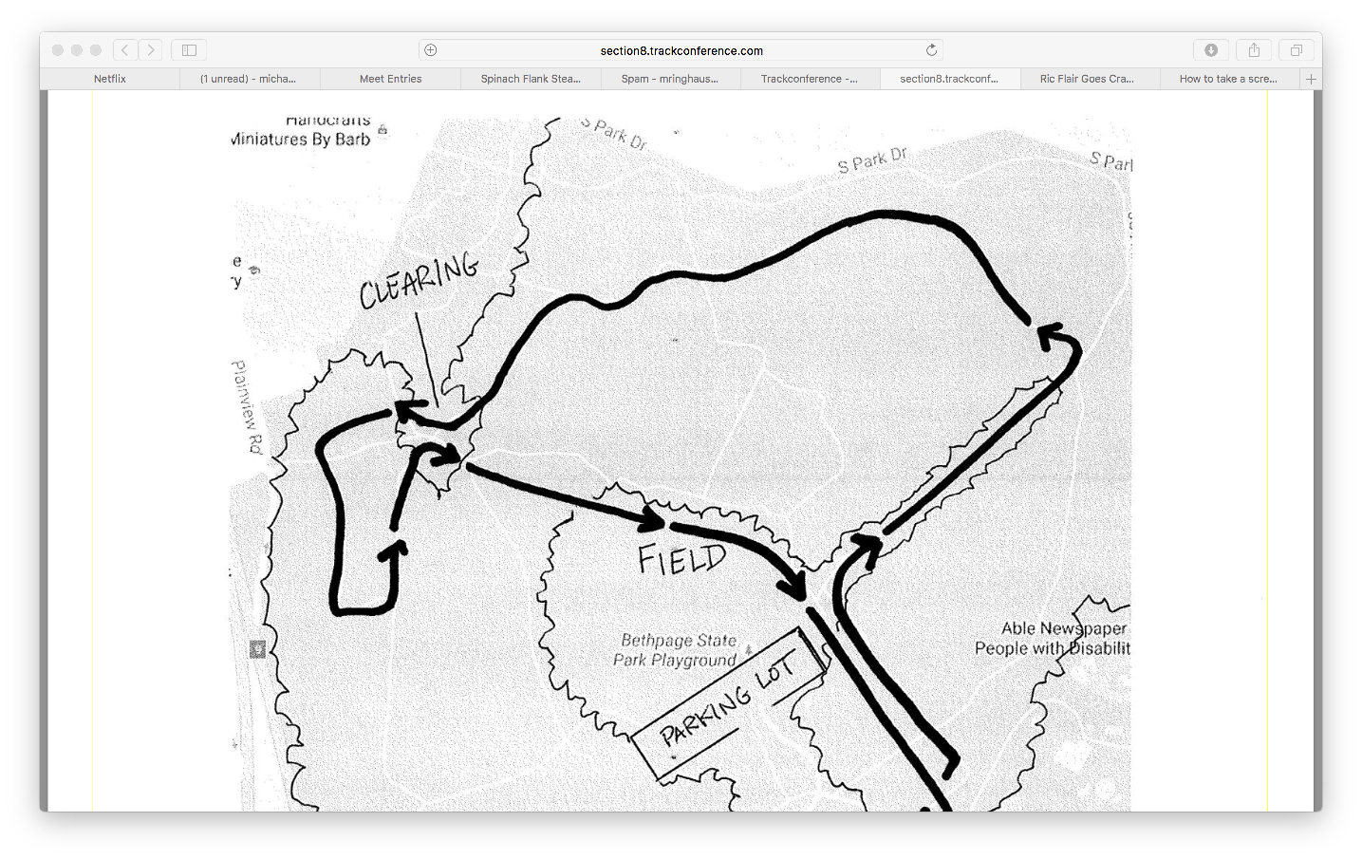

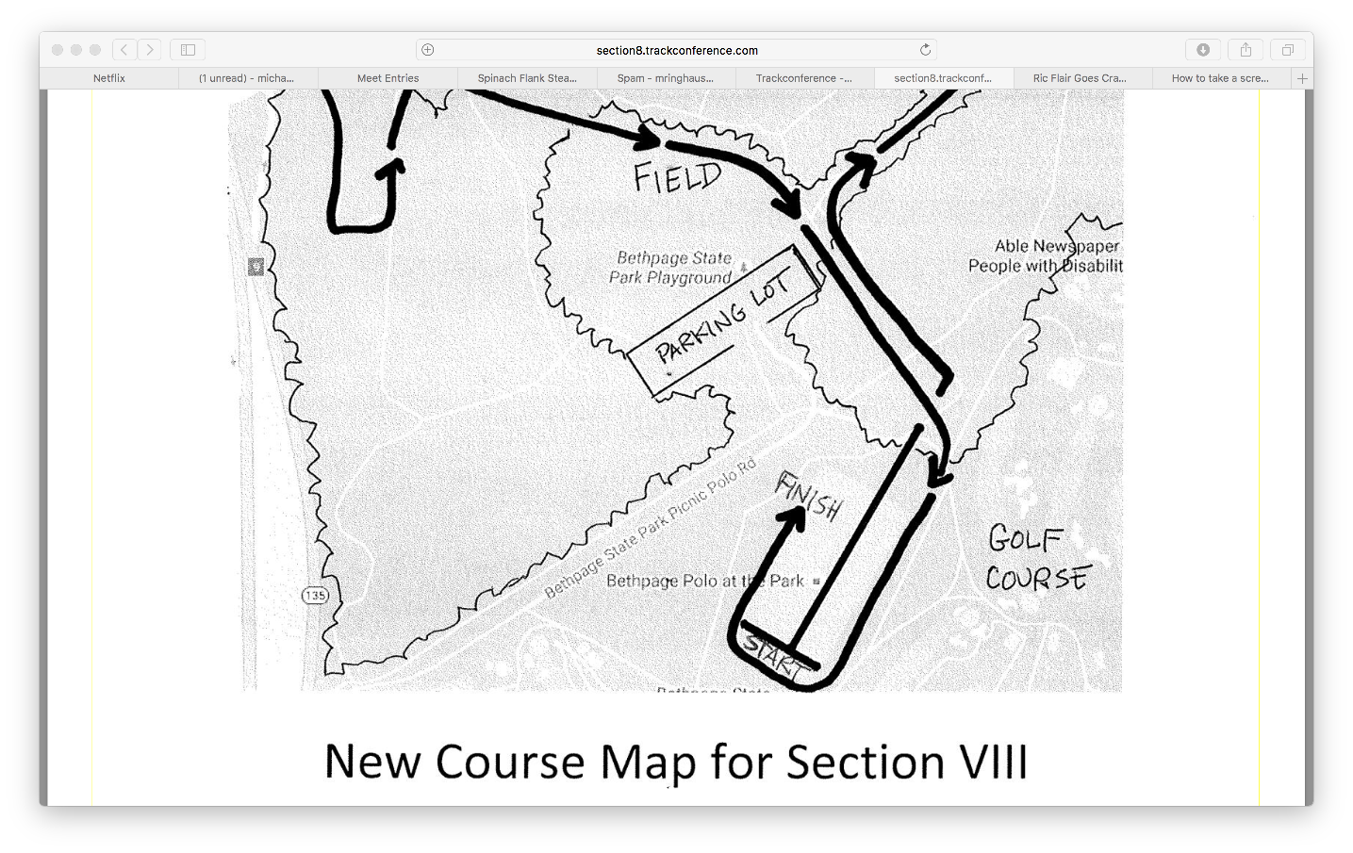

Course Notes:

All races will begin at the polo field with spectators able to see the opening 400m of each race. The runners will then enter into the scenic trails for approximately the next 1.5 miles, with several areas available for coaches and spectators to travel to if wanting to watch. The athletes will then enter into the baseball fields, a brief trail section and a final loop of the polo fields making the last mile of the race visible from several areas on the course. All parts of the race will take place on well-cut grass, trails and woodchips, with one challenging hill just prior to entering the baseball fields.