NEW YORK STATE PUBLIC HIGH SCHOOL ATHLETIC ASSOCIATION
TRACK & FIELD CHAMPIONSHIP MEET

Dear Parent/Guardian:

Congratulations! Your child has qualified to represent Section VIII at the NY State Track & Field Championship on June 9,10 2017. The meet is being held this year at Union Endicott High School. The team from Section VIII will be staying at the Comfort Suites 3401 Vestal Parkway East,
Vestal NY 13850 (607)766 0600
Buses will be leaving promptly from Great Neck South HS on THURSDAY June 8th at 9:30 AM.
DO NOT Arrive BEFORE 8:45 or after 9:15!
341 Lakeville Rd, Lake Success, NY 11020 Phone:(516) 441-4800

CHECK LIST FOR THE BUS:
- Permission Slip
- Code of Conduct (2 pages)
- BRING YOUR LUNCH ON BUS THURSDAY! The bus will not be stopping for lunch.
- School issued uniforms - Relay Team uniforms must be identical.

- All other meals besides breakfasts (Thursday dinner, Friday and Saturday lunch and dinner)
are the responsibility of the athletes.
- Friday and Saturday Lunches-There are concession stands at the meet. Friday night’s
dinner will be at local fast food and other restaurants
- Athletes may purchase programs and meet merchandise on their own.

Return Saturday June 10th
*The buses will return back to Great Neck South HS, at the conclusion of the State Meet. Buses will make one dinner break stop before arriving back at Christopher Morley Park. We expect to return Saturday evening around 8:30PM.

TRIP RULES
- All athletes are under the direct supervision of the Section Coordinators and the Bus Supervisors.
- All athletes are part of the Section 8 Team and if unable to attend must notify the coach as soon as possible.
- This honor was achieved through hard work and you are expected to continue this effort and comply with the following section and state rules:
  - No alcoholic beverages, no smoking, no illegal substances.
  - No inappropriate behavior. No boys in girls’ rooms or vice-versa. Adhere to time schedule and curfews.
  - No large radios, only personal type devices.
  - All travel arrangements, including rooming arrangements must be adhered to.
- Athletes must travel with the transportation provided by Section 8.

PERMISSION SLIP
TRACK & FIELD CHAMPIONSHIP
2017

I HAVE READ THE PERMISSION SLIP AND CODE OF CONDUCT AND AGREE TO HAVE MY

CHILD_____________________________________ ABIDE BY THE RULES SET FORTH BY THE NYSPHSAA AND SECTION VIII.

PARENT SIGNATURE__________________________________________

PARENT CELL PHONE_________________________________________

COACHES SIGNATURE________________________________________

COACHES CELL PHONE________________________________________

ATHLETES SIGNATURE________________________________________

ATHLETES CELL PHONE________________________________________

DATE____/_____/_______
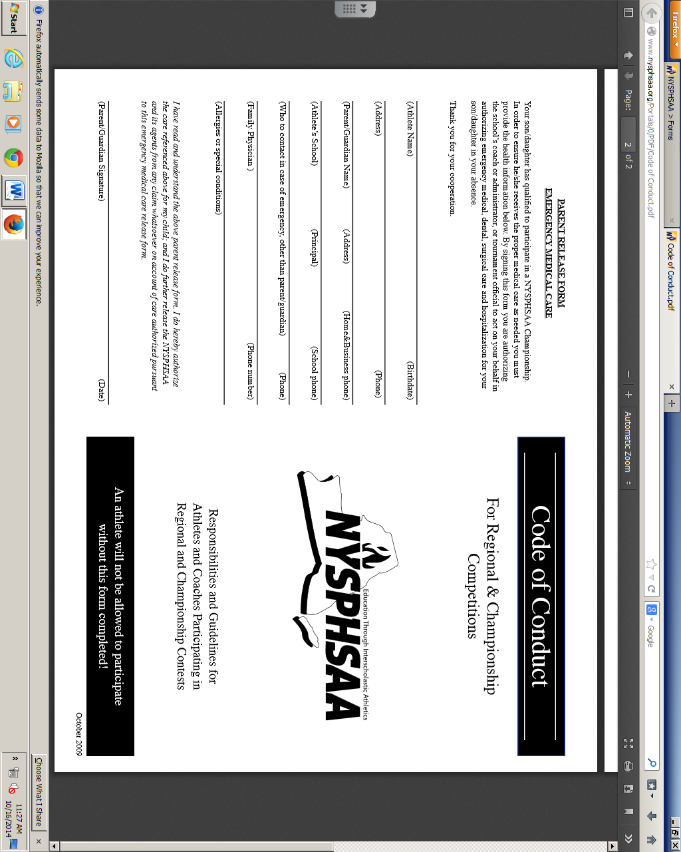

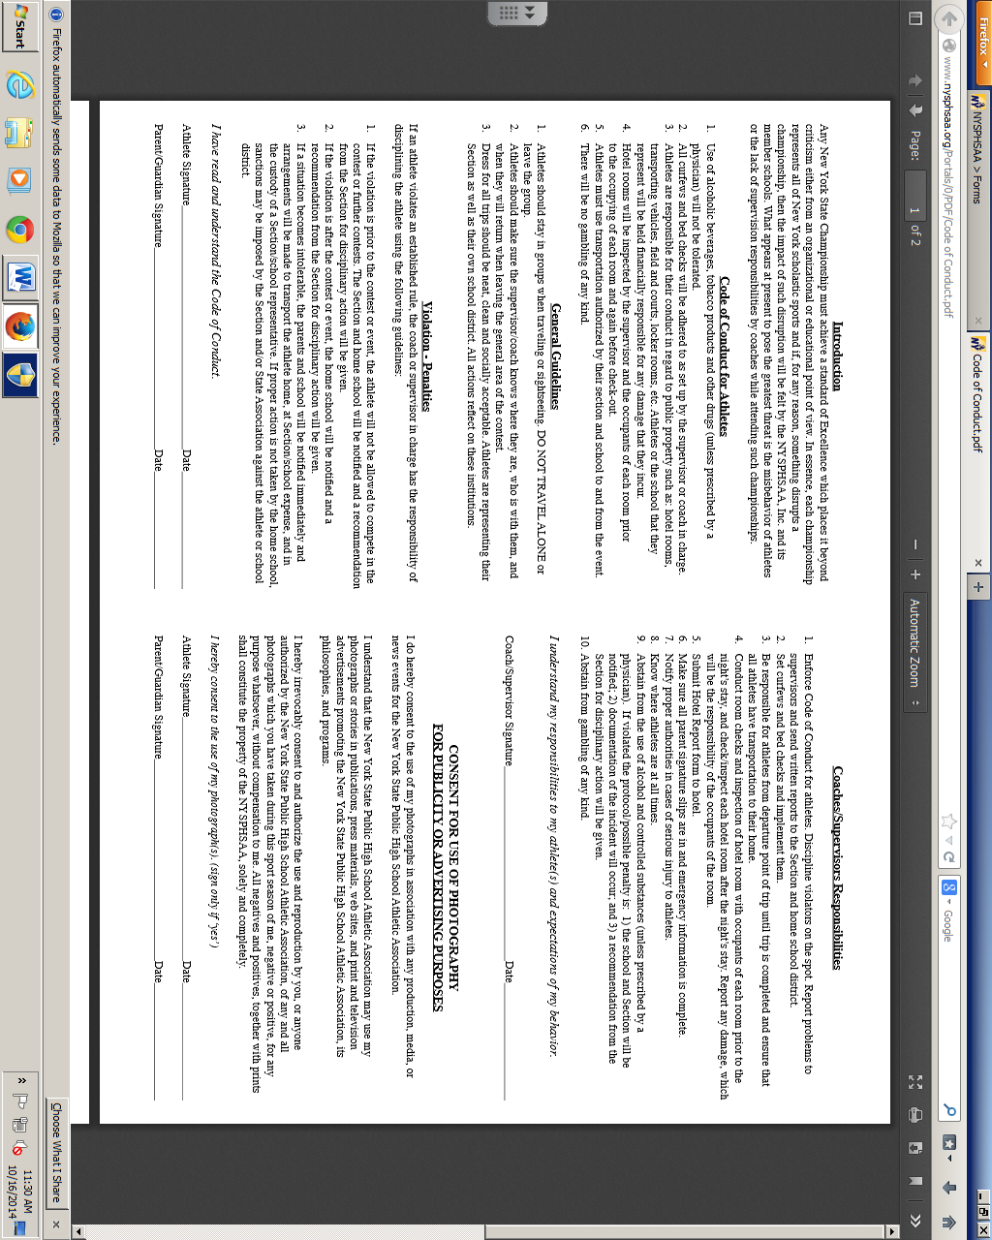

Itinerary for Section VIII Track & Field
NY STATE Championship-Union Endicott HS 2017

Thursday June 8th, 2017
8:45 AM Bus arrives at Great Neck South HS
Bus departs at 9:30 AM.

Bus departs to: Comfort Suites
3401 Vestal Parkway East
Vestal NY 13850
**Athletes will bring their own lunch on the bus**
1:30 PM Bus arrives Comfort Suites Vestal NY

3:45 PM Bus leaves Hotel for Union Endicott HS for afternoon practice.

4:00 PM Practice at Union Endicott HS
6:00 PM Dinner at Local Restaurants and fast Food. Athletes choose.

10:00 Curfew

Friday June 9th, 2017
6:30-9:30 AM Breakfast: (Included) The hotel offers a hot and cold buffet breakfast.

10:30 AM First Bus departs Hotel for the Meet. Athletes will depart hotel based on their event.

12:00PM to State Championship Track Meet. Food will be available at the meet at the athletes own cost.
6:00PM

6:30- 8:30 PM Dinner at Local Restaurants and fast Food. Athletes choose.

10:00 PM Curfew

Saturday June 10th , 2017
7:00-10:00 AM Breakfast: (Included) The hotel offers a hot and cold buffet breakfast.

8:00 AM First Bus departs Hotel for the Meet. Athletes will depart hotel based on their event.

4:00 PM Buses will depart from Union Endicott HS.
Our estimated return to Great Neck South HS will be 8:30 PM

TRANSPORTATION POLICY FOR STATE CHAMPIONSHIPS

1. Section VIII will supply transportation to and from State Championships.

2. Each and every participant representing Section VIII is required to travel by the transportation provided by the Section.

3. No sports coordinator (or his/her designee), coach or supervisor has the authority to release the student/athlete from traveling on the transportation provided by the Section.

4. Exception: In the event that a student/athlete requests not to travel by Section sponsored transportation, the following procedure must be followed:

a) The student/athlete must submit a written request to be released to the custody of their parent/guardian to his/her coach stating the reason for not traveling with the Section and signed by the parent/guardian.

b) If the coach approves this request, he/she will submit the request to the district director, building director and building principal for their written approval.

c) Once the request is approved in writing by those administrators listed in b), the coach will submit this written approval to the Section Sports Coordinator(s) (or his/her designee) with a copy to the Executive Director.

d) This then relieves the Section and its sports coordinator(s) or designee of being liable for making a decision he/she cannot control.

