The 51st Annual Nassau Coaches Invitational
Saturday, April 6th, 2019 – Cold Spring Harbor H.S. (9am Start)

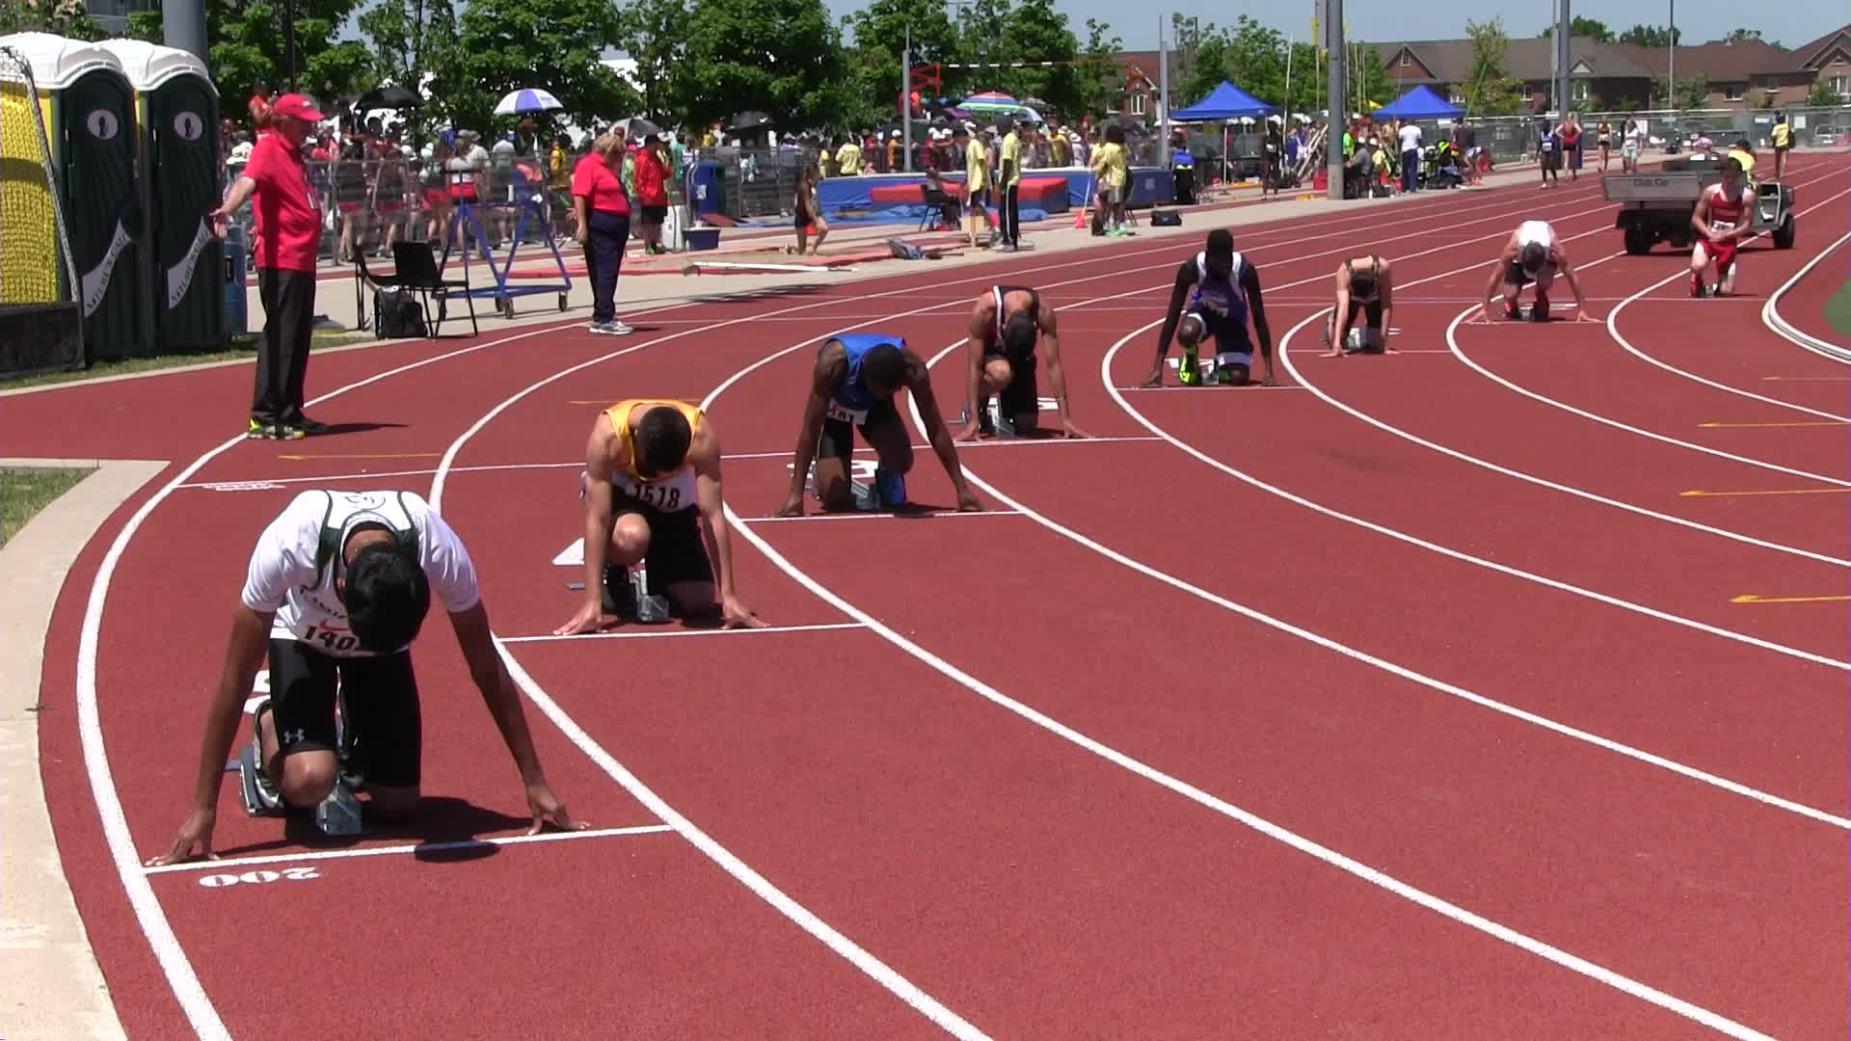

NCTCA Officers: Board of Directors:
President Michael Ringhauser (EM) Adam McKenzie (Great Neck North)
Vice President Kristin Frazer (Section Coord.) Dennis Kornfield (Uniondale)
Treasurer Fred DeRuvo (Island Trees) Bob Busch (Ex Officio)
Secretary Katie DeRuvo

The Cold Spring Harbor School District has provided us with an outstanding site, tremendous cooperation, and generous support for this event. We should express our appreciation for their role and treat their site and personnel with the utmost respect. We ask that you leave your team’s space as clean as you found it. We thank the Cold Spring Harbor track coaches and student-athletes for their cooperation and assistance throughout the invitational.

BACK THIS YEAR:
FAT results for all events posted on www.just-in-time-racing.com as well as at the meet itself.

Meet Directors: Michael Ringhauser (EM) and Nick Aurigemma (CSH)

The Nassau County Track Coaches Association
51st Annual Track and Field Invitational
Saturday, April 6th, 2019 – Cold Spring Harbor High School (9am Start)

Meet Directors: Michael Ringhauser and Nick Aurigemma
- This meet is co-sponsored by the NCTCA and Cold Spring Harbor High School
- All Section VIII, NYSPHSAA, and National Federation rules are enforced
- Certified NYS Officials will be present at all events contested
- Decision of the jury is final on all appeals at the invitational
- Medical Staff will be on-site

Seeding: Running Events – Labels needed with name, competitor number, school.
Field Events – 3x5 index cards with name, competitor number, school, seed.
Relays – 3x5 index cards with names, competitor numbers, school, and seed.
Outside schools must have their roster entered onto just-in-time-racing.com.

Fr/So Events: Limited to runners in 7th, 8th, 9th and 10th grade.
Please note that 7th and 8th grade competitors must have gone through the classification process and be on your varsity roster to be able to compete.

Awards: Medals to the Top 6 finishers in ALL EVENTS!
School Plaque to FASTEST OVERALL TIME in the three OPEN RELAYS.

Field Events: All first attempts will be measured. After that, athletes must reach the standards below in order to receive a measurement.

Open Shot Put Boys – 35 Girls – 25
F/S Shot Put Boys – 30 Girls – 20
Open Discus Boys – 90 Girls – 75
F/S Discus Boys – 80 Girls – 60
Open Long Jump Boys – 17 Girls – 14
F/S Long Jump Boys – 15 Girls – 12
Open Triple Jump Boys – 36 Girls – 28
F/S Triple Jump Boys – 32 Girls – 24

Note: Please submit all paperwork as soon as possible. DO NOT ASSUME THAT YOUR SCHOOL WILL SEND US A COPY – as the coach, YOU must send us a copy!

Questions: Michael Ringhauser (Phone) 631-245-1564
(Email) michael.ringhauser@yahoo.com

ALL ENTRIES ARE DUE BY WEDNESDAY, APRIL 3rd, 2019.
LATE ENTRIES MAY NOT BE ACCEPTED INTO THE INVITATIONAL.

2019 Nassau Coaches Invitational Order of Events:
Boys, then Girls in All Running Events

400 Hurdles Final – Open Only

1600/1500 Final – Open, Sophomores, Freshmen

100 Semi-Final – Open Only

110/100 Hurdles Final – Open Only

400 Final – Open, Sophomores, Freshmen

100 Final – Two Sections

800 Final – Open, Sophomores, Freshmen

200 Final – Open Only

2000 Steeple Chase Final – Open Only
- Please note that this event will only be contested if the temperature is above freezing. We will try our best to make that determination the day before the meet and post on www.trackconference.com.

4x400 Final – Open, Frosh/Soph

4x800 Final – Open, Frosh/Soph

4x100 Final – Open, Frosh/Soph

Field Event Order: * Unseeded sections may have reduced opportunities based on time.
9AM Open Long Jump Girls, then Boys
Open Triple Jump Boys, then Girls
Open Shot Put Girls, then Boys
Open Discus Boys, then Girls
Open and Frosh/Soph High Jump Boys, then Girls (Combined; Separated in Results)
Open and Frosh/Soph Pole Vault Girls, then Boys (Combined; Separated in Results)

All Frosh/Soph Field Events (Besides HJ and PV) will be called after the completion of the Open.
Frosh/Soph Long Jump Girls, then Boys
Frosh/Soph Triple Jump Boys, then Girls
Frosh/Soph Shot Put Girls, then Boys
Frosh/Soph Discus Boys, then Girls

REMEMBER THAT CARDS ARE NEEDED FOR ALL FIELD EVENTS!
Information Needed: Athlete’s Name, School, Competitor Number, Seed

Nassau Coaches Invitational Entry Grid
PLEASE FILL THIS OUT ACCURATELY SO WE CAN EFFICITENTLY MANAGE TIME!
Boys and Girls Must Use Separate Entry Forms!
EVENT | OPEN | SOPH | FROSH | FRESH/SOPH
400 Hurdles |  | NA – XXXXXX | NA – XXXXXX | NA – XXXXXX
1600/1500 |  |  |  | NA – XXXXXX
100 |  | NA – XXXXXX | NA – XXXXXX | NA – XXXXXX
110/100 H |  | NA – XXXXXX | NA – XXXXXX | NA – XXXXXX
400 |  |  |  | NA – XXXXXX
800 |  |  |  | NA – XXXXXX
Steeple Chase |  | NA – XXXXXX | NA – XXXXXX | NA - XXXXXX
200 |  | NA – XXXXXX | NA – XXXXXX | NA – XXXXXX
High Jump |  | NA – XXXXXX | NA – XXXXXX
Long Jump |  | NA – XXXXXX | NA – XXXXXX
Triple Jump |  | NA – XXXXXX | NA – XXXXXX
Pole Vault |  | NA – XXXXXX | NA – XXXXXX
Shot Put |  | NA – XXXXXX | NA – XXXXXX
Discus |  | NA – XXXXXX | NA – XXXXXX
4x400 |  | NA - XXXXXX | N/A - XXXXX
4x800 |  | NA – XXXXXX | NA – XXXXXX
4x100 |  | NA – XXXXXX | NA – XXXXXX

School: __________________________________ Boys/Girls: __________________________

Coach: __________________________________ Phone: _____________________________

Email: ___________________________________ School Phone: _______________________

Billing Information: All fees associated are considered ENTRY FEES, not participation fees.
Make All Checks Payable to: NCTCA
The cost of officials will be billed through BOCES
- Non-Section VIII schools will be billed $50 for officials.
Option One:
Number of Individuals _____ x $5.00 = ____________________________________

Number of Relays _____ x $20.00 = ____________________________________

Option Two: BLANKET ENTRY OF $250 PER TEAM (NOT PER SCHOOL)
Note that this is $100 cheaper than previous years in order to help our teams.
YOU STILL HAVE TO FILL OUT A GRID FOR MEET MANAGEMENT.

Total Owed: __________________________ (Non-Section VIII Schools Add $50 for Officials)

Send Entries and Payment To: Fred DeRuvo Fax Fred DeRuvo
730 Boelsen Drive OR (516) 334-5461
Westbury, NY 11590 FAX BEFORE 9PM ONLY

