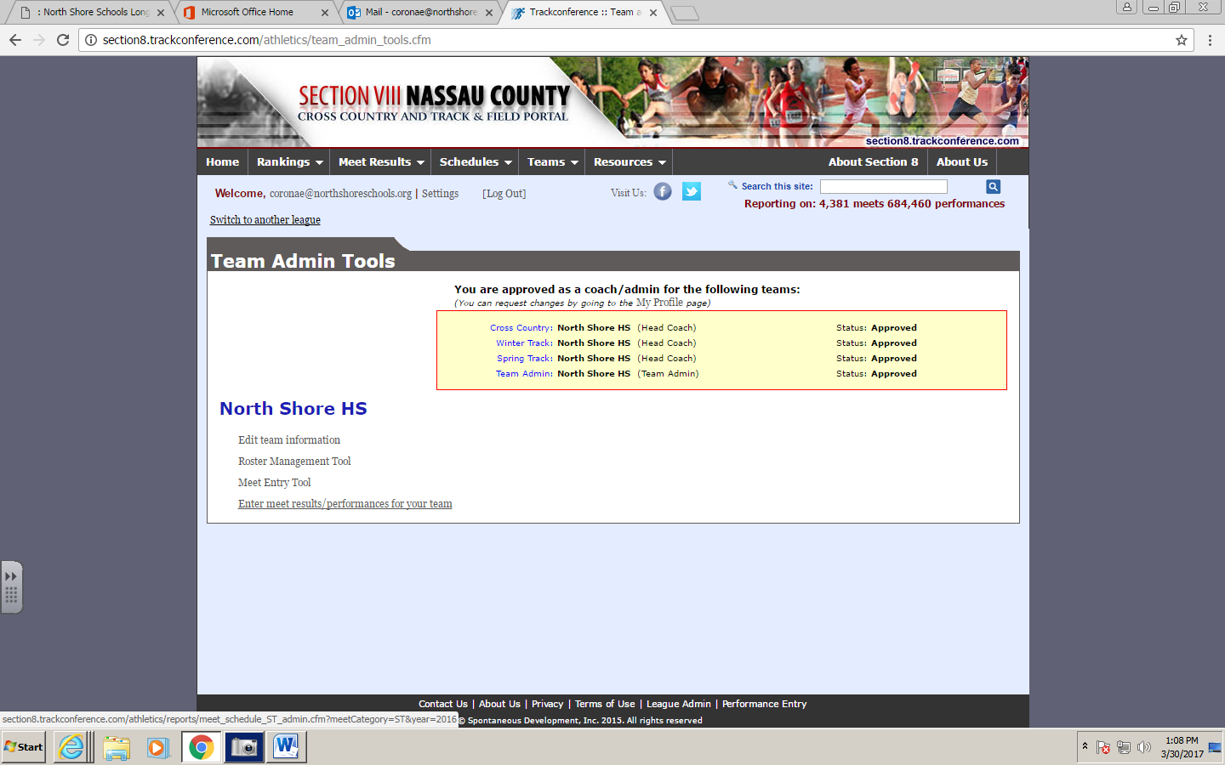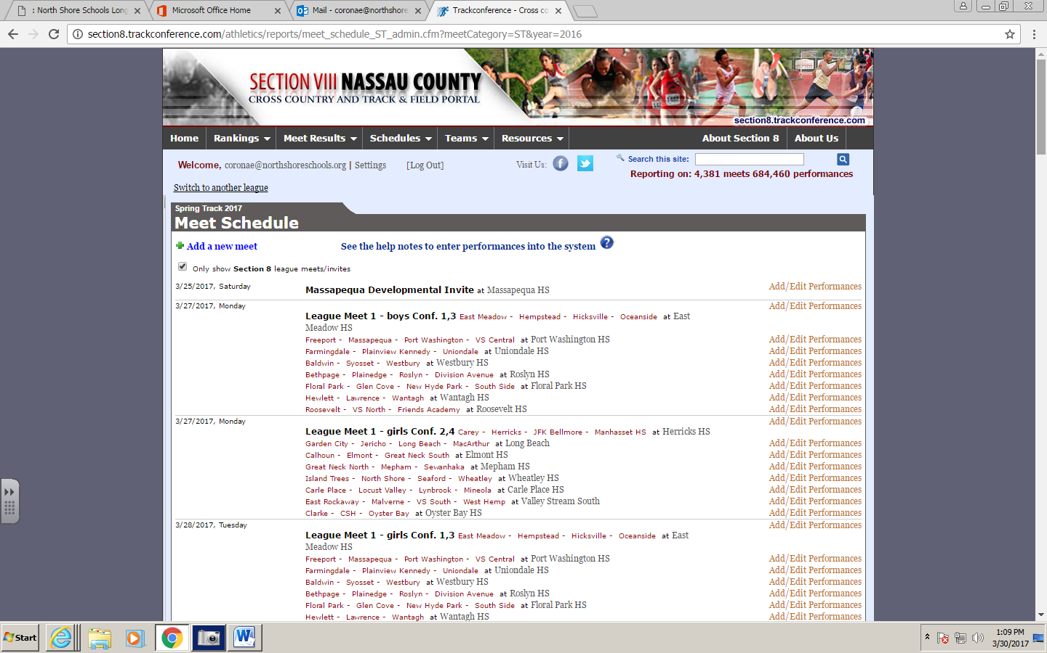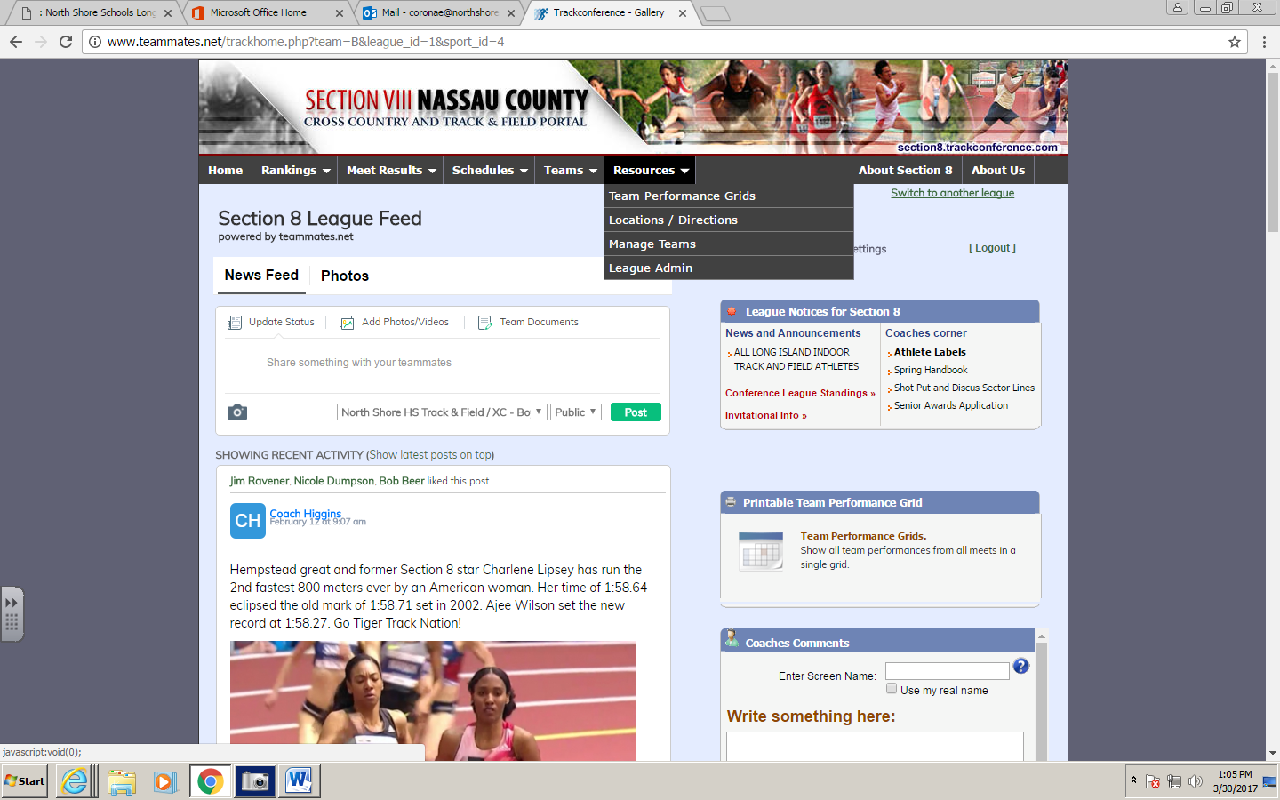

**STEP 3**

**Find your meet and**

**Add/Edit Performances**

**STEP 2**

**Find Enter meet results/performances for your team**

**HOW TO ADD PERFORMANCES TO MEETS**

**STEP 1**

**Log In and under RESOURCES**

**Choose MANAGE TEAMS**