**The 54th Annual Nassau Coaches XC Invitational**

**Saturday, October 16th, 2021 – Bethpage State Park**

*All races will be contested over the Scenic 5k Course (Map Attached)*

Meet Notes:

1. Schools may run multiple varsity teams, with each team consisting of up to 7 runners. Multiple team entries will be equally divided between BOTH varsity sections. Individual entries in the freshmen, sophomore and junior varsity races are unlimited.
2. All fees associated with the invitational are **ENTRY**, not participation fees.
3. Competing schools will split the cost of officials with non-Section VIII schools being charged $25 toward that cost.
4. Coaches will be allowed to go where ever they wish on the course provided that you are not on the race path itself or interfering with the race. Spectators will be allowed in pre-selected areas discussed during the coaches meeting.
5. Our course will be VERY WELL marked off for outside schools competing!

**Invitational Awards:**

* **Medals** to the **Top 50 Individuals** in All Races – Handed Out at the End of the Chute at the Conclusion of Each Race
* **Trophy** for the **Fastest Time of the Day** (One Boy, One Girl)
* **Trophy** for the **Fastest 5th Man of the Day** (One **Varsity** Boy and Girl)
* **Trophies** to the **Top 3 Teams** in the Freshmen, Sophomore, and Varsity

*Please Note - No Team Awards Given for the Junior Varsity Races!*

* **T-Shirts** for **Winning Varsity, Freshmen and Sophomore Teams & Coach**

**Additionally We Will Return: THE ALL INVITATIONAL TEAM!**

We will be presenting an ALL-INVITATIONAL TEAM comprised of the Top 7 Overall Runners in the Freshmen, Sophomore and Both Varsity Races. **Invitational Cow Bells** will be given out at the end of the chute at the conclusion of each race!

**Rosters:**

* Nassau County schools will use their assigned racing bibs from Elite Feats.
* Teams outside of Nassau County will have to send a roster of **competing athletes** to EliteFeats so racing bibs can be created. *Please only enter the athletes racing at the invitational as we have to pay for each bib created!*

**Parking:**

Bethpage State Park will charge for parking with the cost for cars being $8 and bus parking costing $75 without a pre-purchased pass. Section VIII teams should buy the pass themselves as listed in the handbook. Non-Section VIII teams should purchase the pass from the Coaches Association which can be done on the entry.

**If you do not purchase a parking pass your bus will not be allowed in the park!**

**The 54th Annual Nassau Coaches XC Invitational**

**Saturday, October 16th, 2021 – Bethpage State Park**

*Invitational Schedule*:

Coaches Meeting (Finish Line) 8:45 am

Boys Freshmen 9:00 am

Girls Freshmen 9:05 am

Boys Sophomore 9:25 am

Girls Sophomore 9:30 am

Boys Junior Varsity 9:50 am

Girls Junior Varsity 9:55 am

Boys Varsity “A” 10:15 am

Girls Varsity “A” 10:20 am

Boys Varsity “B” 10:45 am

Girls Varsity “B” 10:50 am

All athletes should report to the starting line ready to race with their issued EliteFeats racing bib. Runners must cross over the entry mat, located at the start line, so that their bib is entered into the EliteFeats’ results program.

**Varsity Seeding**:

**Requests for seeding in the varsity races must accompany your entry.** We will try to accommodate all requests, however, the final decisions will be made with the goal to have two equally competitive varsity sections. Varsity race assignments will be posted by October 14th on the Section VIII website and via email. **There will be NO CHANGES to the assigned races on the day of the invitational.**

**Questions?**

Michael Ringhauser, NCTCA President

[michael.ringhauser@gmail.com](mailto:michael.ringhauser@gmail.com) or (631) 245-1564

**The 54th Annual Nassau Coaches XC Invitational**

**Saturday, October 16th, 2021 – Bethpage State Park**

**Entries must be received by Wednesday, October 13th, 2021.**

**Please use separate entries for boys’ and girls’ teams.**

Circle One: BOYS ENTRY GIRLS ENTRY

School: ________________________________________________________________________________

Address: ________________________________________________________________________________

Coach: ______________________________________________ Phone: _______________________

E-mail: ________________________________________________________________________________

**Freshmen** # of Runners __________ x $7 = $ _______________

**Sophomores** # of Runners __________ x $7 = $ _______________

**Junior Varsity** # of Runners __________ x $7 = $ _______________

**Varsity Team** # of Teams __________x $50 = $ _______________

**NON-SECTION VIII TEAMS ADD $25 FOR OFFICIALS** = $ _______________

*Section VIII teams will split the cost of officials and be billed through BOCES.*

**ADD $35 IF PURCHASING A BETHPAGE BUS PASS** = $ _______________

***TOTAL ENTRY FEE*** = $ _______________

Checks Payable: Nassau County Track Coaches Association (NCTCA)

Tax ID: 421705038

Mail Entries: Fred DeRuvo Fax Entries: Fred DeRuvo

730 Boelsen Drive 516-334-5461

Westbury, NY 11590 (9am – 7pm Only)

Questions: Michael Ringhauser, NCTCA President

Phone – (631) 245-1564

E-mail – [michael.ringhauser@yahoo.com](mailto:michael.ringhauser@yahoo.com)

**Coaches: PLEASE SEND A COPY OF YOUR TEAM’S ENTRY TO US!**

**Bethpage State Park Course Map**

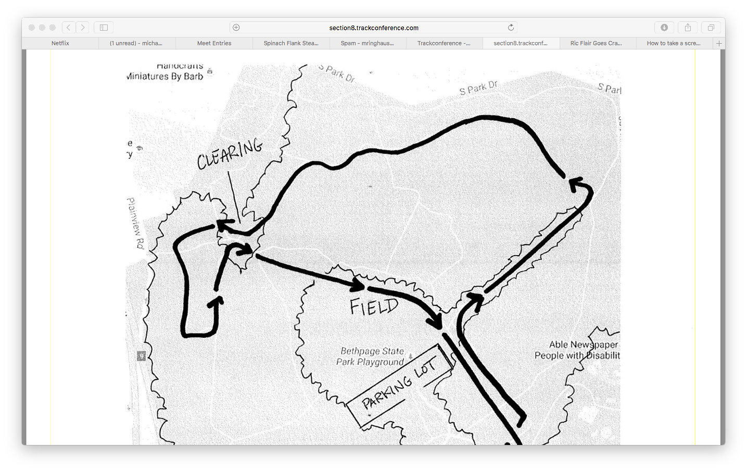

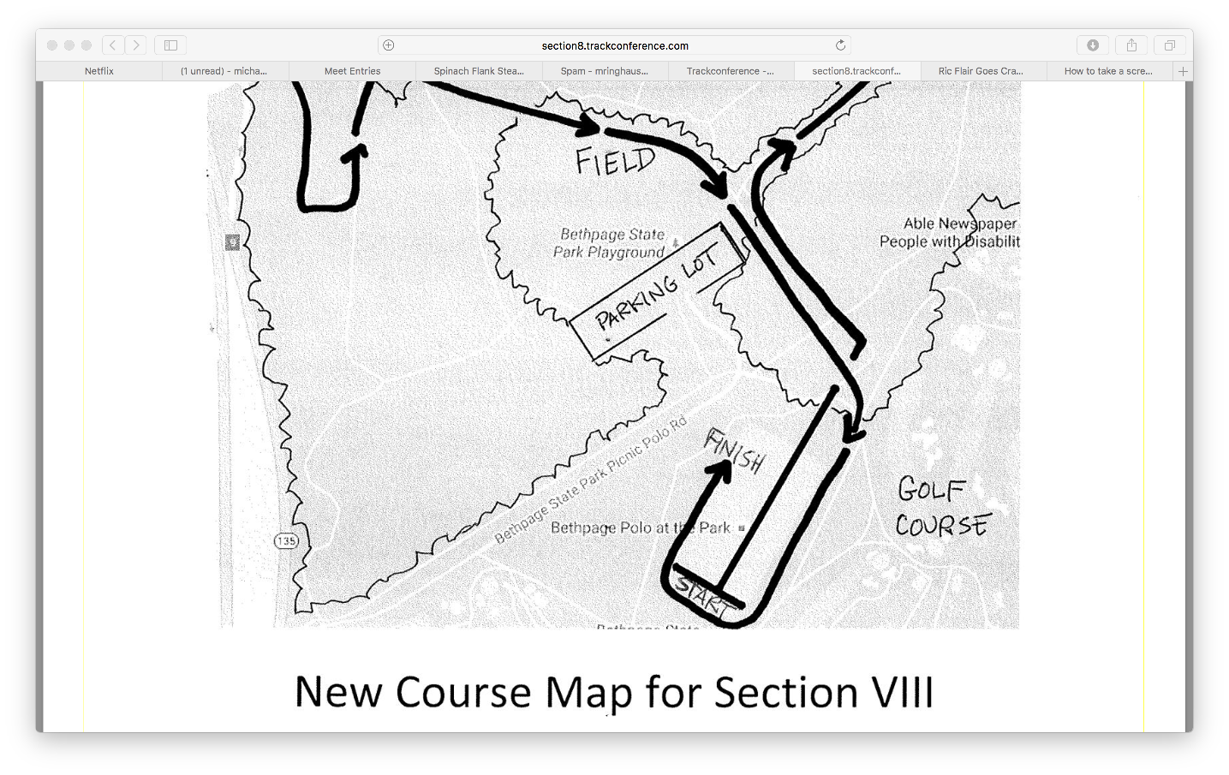

Course Notes:

All races will begin at the polo field with spectators able to see the opening 400m of each race. The runners will then enter into the scenic trails for approximately the next 1.5 miles, with several areas available for coaches and spectators to travel to if wanting to watch. The athletes will then enter into the baseball fields, a brief trail section and a final loop of the polo fields making the last mile of the race visible from several areas on the course. All parts of the race will take place on well-cut grass, trails and woodchips, besides two very brief road crossings. with one challenging hill just prior to entering the baseball fields. Spikes are encouraged.