**Nassau County High School Athletic Association**

Section VIII of the NYSPHSAA

Patrick Pizzarelli, Executive Director



**Boys and Girls Spring Track & Field Handbook – 2018**

Boys Coordinator – Ed Corona, North Shore High School

Girls Coordinator – Nick Aurigemma, Cold Spring Harbor High School

**Section VIII Spring Track & Field Committee**

**Conference 1** Rich Degnan, Massapequa High School

Steve Josepher, East Meadow High School

Michael Howley, Oceanside High School

Chris Meyers, Syosset High School

**Conference 2** Dave Hendler, Calhoun High School

Adam McKenzie, Great Neck North High School

Greg Milone, Long Beach High School

Matt Princi, Carey High School

Steve Steiner, Manhasset High School

**Conference 3** James Ravener, Bethpage High School

Matt Carbone, Glen Cove High School

Kristen Hamilton, Roslyn High School

Stephen Honerkamp, Hewlett High School

**Conference 4** Neal Levy, North Shore High School

Pete McNally, Lynbrook High School

Fred DeRuvo, Island Trees High School

Thomas Leninger, Mineola High School

Kevin Cotter, Oyster Bay High School

**High School Association Representative**

Ralph Amitrano, Mineola High School

**Representatives from the Officials Associations**

Jim Restaino, President, Boys Officials Association

Connie Champlin, President, Girls Officials Association

**Modified Track & Field Coordinator**

TBA

**Nassau County Track Coaches Association**

**President** Michael Ringhauser, East Meadow High School

**Vice President** Kristin Frazer, Wantagh High School

**Treasurer** Fred DeRuvo, Island Trees High School

**Secretary** Katie DeRuvo, Wheatley High Schools

**Boys & Girls Spring Track & Field Handbook**

Section 1 page 3 - 4 Season Overview and Alignments

Section 2 page 5 - 6 Notable Rules and Seed Information

Section 3 page 6 Timing Services, Results and Website

Section 4 page 7 - 11 League Meets and League Meet Schedule

Section 5 page 12 Track & Field Invitationals

Section 6 page 13 Section VIII “North Shore/South Shore” Frosh & Soph Meets

Section 7 page 14- 15 Division Championships and Division Meet Entry Form

Section 8 page 16 - 17 Class County Championships

Section 9 page 18 - 19 State Qualifying Meet

Section 10 page 20 - 24 NYSPHSAA State Meet Information

Section 11 page 25 - 27 Forms

1. Medical Waiver – page 25
2. Pole Vault Certification Form – page 26
3. League Meet Results – page 27

**2018 Important Dates**

March 5 First day of practice

March 8 Mandatory Spring Track & Field Coaches Meeting

March 23 Rosters due online at www.TrackConference.com

March 26,27 League Meets begin

April 9 Section VIII Frosh/Soph Meets (North Shore/South Shore)

May 14,15,16,17 Division Championships

May 22,23,24 County Championships

May 30, June 1 State Qualifier

June 8,9 State Championships

June 12 Spring Awards Dinner

**Sportsmanship**

The NYSPHSAA requires Officials to enforce all rules regarding unsportsmanlike conduct by coaches and athletes. There will be no tolerance for negative statements or actions between opposing players, especially trash- talking, taunting, or baiting of opponents. Please remind all athletes and coaches of this policy.

**Safety Notes**

*NY State Thunder & Lightning Policy* – At the first sign of lightning, or sound of thunder, the event must come to halt. Everyone should retire to their buses or a nearby building. The event may resume when there is no lightning or thunder for 30 minutes. Meet management will decide if the meet is to be postponed completely. *Heat Index Policy* – Coaches should be aware of the NYSPHSAA Heat Index procedures. Recommendations are made by the State when the Real Feel Temperature (Heat Index) is 80 degrees or higher. Please contact your Athletic Director for more information.

**Section 1 – Season Overview**

|  |  |  |  |
| --- | --- | --- | --- |
| **Conference 1** | | **Conference 2** | |
| **Division 1A** | **Division 1B** | **Division 2A** | **Division 2B** |
| 1. Freeport * | 2. Westbury* | 1. Long Beach | 2. New Hyde Park |
| 3. Uniondale | 4. Port Washington | 3. Valley Stream Central | 4. Elmont |
| 5. Hempstead | 6. Hicksville | 5. Calhoun | 6. Carey |
| 7. Massapequa | 8. Plainview-JFK | 7. Mepham | 8. Garden City |
| 9. Syosset | 10. Baldwin | 9. Great Neck South | 10. Great Neck North* |
| 11. Farmingdale | 12. East Meadow | 11. Mac Arthur* | 12. South Side |
| 13. Oceanside  15. (bye) | 14. Herricks  16. (bye) | 13. Manhasset  15. (bye) | 14. Jericho  16. (bye) |
| **Conference 3** | | **Conference 4** | |
| **Division 3A** | **Division 3B** | **Division 4A** | **Division 4B** |
| 1. Sewanhaka | 2. Wantagh | 1. Lynbrook* | 2. Seaford |
| 3. Bellmore-JFK | 4. Levittown Division* | 3. North Shore | 4. Cold Spring Harbor* |
| 5. Hewlett* | 6. Friends Academy | 5. Valley Stream South | 6. Wheatley |
| 7. Glen Cove | 8. Floral Park | 7. Mineola | 8. Malverne |
| 9. Roslyn | 10. Bethpage | 9. Clarke | 10. Oyster Bay |
| 11. Roosevelt | 12. Lawrence | 11. Island Trees | 12. Carle Place |
| 13. Plainedge | 14. Valley Stream North | 13. West Hempstead | 14. East Rockaway |
| 15. (bye) | 16. (bye) | 15. Locust Valley | 16. Academy Charter |

*Division Meet hosts are starred Underlined schools have pole vault facilities

|  |
| --- |
| **Section VIII Class County Alignment** **New York State Alignment**  AAA = Freeport through Great Neck South State Division 1 =Freeport through Mineola  AA = MacArthur through Friends Academy plus Friends Academy (Div 1)  A = Floral Park through Academy Charter State Division 2 = Clarke through Academy Charter |

|  |  |  |  |  |
| --- | --- | --- | --- | --- |
| **Conference League Meet Schedule** | | | | |
| **League Meet #1**  March 26 & 27  3-8-13-2  4-7-14-1  5-10-11-16  6-9-12-15 | **League Meet #2**  April 11 & April 12  3-10-12-1  4-9-11-2  5-8-14-15  6-7-13-16 | **League Meet #3**  April 16 & April 17  3-4-5-6  7-8-9-10  11-12-13-14  15-16-1-2 | **League Meet #4**  April 23 & April 24  3-9-14-16  4-10-13-15  5-7-12-2  6-8-11-1 | **League Meet #5**  April 30 1 & May 1  3-7-11-15  4-8-12-16  5-9-13-1  6-10-14-2 |
| **Mondays = Girls Conference 1 & 3, Boys Conference 2 & 4** | | | | |
| **Tuesdays = Girls Conference 2 & 4, Boys Conference 1 & 3** | | | | |

**Section VIII Frosh/Soph Meet** North Shore’ Schools – on April 9 at North Shore High School

South Shore’ Schools – on April 9 at Oceanside High School

**Division Championships** Division 4A and 4B meets – on May 14 at starred* sites above

Division 2A and 2B meets - on May 15 at starred* sites above

Division 1A and 1B meets – on May 16 at starred* sites above

Division 3A and 3B meets – on May 17 at starred* sites above

**County Championships**

Class A – on May 24 at CSH High School

Class AA – on May 23 at MacArthur High School

Class AAA – on May 22 at Long Beach

**State Qualifier Meet** Division 1 & 2 – on May 30 and June 1 at North Shore High School

**State Championship** Division 1 & 2 – on June 8 and 9 at Cicero North Syracuse HS

**Spring Track & Field 2018 Section VIII of the NYSPHSAA**

|  |  |  |  |  |
| --- | --- | --- | --- | --- |
| **2018 Section VIII Spring Track & Field County Classes** | | | | |
| **County Class AAA** |  | **County Class AA** |  | **County Class A** |
| Freeport  Hempstead  Uniondale  Massapequa  Syosset  Farmingdale  Oceanside  Hicksville  Port Washington  Baldwin  East Meadow  Plainview-JFK  Westbury  Valley Stream Central  Long Beach  Herricks  Calhoun  Mepham  Great Neck South |  | Macarthur  Manhasset  Bellmore-JFK  Garden City  Great Neck North  Carey  Elmont  Sewanhaka  Jericho  New Hyde Park  Roslyn  Hewlett  South Side  Roosevelt  Wantagh  Division Avenue  Plainedge  Glen Cove  Friends Academy |  | Floral Park  Lawrence  Valley Stream North  Bethpage  Lynbrook  North Shore  Valley Stream South  Mineola  Clarke  West Hempstead  Island Trees  Seaford  Locust Valley  Cold Spring Harbor  Wheatley  Malverne  Oyster Bay  Carle Place  East Rockaway  Academy Charter |

|  |  |  |  |
| --- | --- | --- | --- |
| **2018 NYSPHSAA Spring Track & Field State Divisions** | | | |
| **State Division 1 (600+)** | |  | **State Division 2 (<600)** |
| Freeport  Hempstead  Uniondale  Massapequa  Syosset  Farmingdale  Oceanside  Hicksville  Port Washington  Baldwin  East Meadow  Plainview-JFK  Westbury  Valley Stream Central  Long Beach  Herricks  Calhoun  Macarthur  Mepham  Great Neck South  Manhasset  Bellmore-JFK  Garden City | Great Neck North  Carey  Elmont  Sewanhaka  Jericho  New Hyde Park  Roslyn  Hewlett  South Side  Roosevelt  Wantagh  Division Avenue  Plainedge  Glen Cove  Friends Academy  Bethpage  Lawrence  Valley Stream North  Floral Park  Lynbrook  North Shore  Valley Stream South  Mineola |  | Clarke  Island Trees  West Hempstead  Locust Valley  Seaford  Cold Spring Harbor  Wheatley  Malverne  Oyster Bay  Carle Place  East Rockaway  Academy Charter |

**Section 2 – Notable Rules (Section VIII follows NFHS, NYSPHSAA and Section VIII guidelines)**

**Competition**

1. Individual must compete in 6 meets representing their HS in order to be eligible for Class Counties. A Medical Waiver is possible, please see Section VIII Directory.
2. Section VIII athletes are allowed to compete in four events in invitationals outside of Nassau County in which the individual meet limit is four events. However, no Section VIII school may host a meet with more than a three event limit.
3. Section VIII meets take precedence over any and all outside meets.
4. An athlete who competes under a competitor number assigned to another athlete (assumed name) will risk disqualification from the meet and risks further sanctions against himself and his or her coach.

**Uniforms**

1. Uniforms consist of a school issued shirt and shorts.
2. Visible undergarments worn underneath a singlet must be a solid color. An undergarment worn on the bottom under a pair of shorts must be a single solid color ONLY if it goes below the knee. Any undergarment worn above the knee is considered “underwear” and not to be looked at for a rules violation.
3. Relay members must have identical uniforms.

**Participation/Eligibility Standards**

1. Ten team practices are required before the first meet or scrimmage.
2. Each individual athlete must have ten practices before competing.
3. Each athlete is limited to 15 meets (exclusive of Counties, State Q’s and the State Meet). Meets after the County Championships, for example Eastern States Invitational, also count toward the 15.
4. There are no independent athletes in Nassau County.
5. The rule of one night’s rest between meets is in effect for the spring, three meets max per week.
6. A school board approved coach must be present for the team/individual to compete in a meet.

**Clerking Responsibilities (Please share this info with your athletes)**

1. All competitors are to report promptly to the clerking area or send a teammate once the event is called. It is the athlete’s responsibility to clerk on time. Once an event is clerked, that event is closed.
2. Athletes should come to the clerking area ready to compete (running apparel and shoes).
3. It is the athlete’s responsibility to notify the clerk if he/she is leaving the clerking area to compete in a field event.
4. No electronics in the clerking area. No cell phones, iPod, etc.

**Media**

1. MSG Varsity & Verizon FiOS TV Contract: The Section VIII contract is for Counties and State Q’s ONLY
2. MSG Varsity & Verizon FiOS: News clips are OK. Featured stories can only be at playoffs.
3. State Meet Journal: [wherenow.nysphsaa@gmail.com](mailto:wherenow.nysphsaa@gmail.com). Coaches can submit bios and pictures of past State Meet athletes to be included in a new feature spotlighting past champions/participants.
4. Coaches should exercise careful discretion when posting on social media sites, blogs and online forums to ensure that all communications are clearly within the code of ethics for coaches as outlined in NYSPHSAA, Section VIII and school district guidelines.

**Electronics**

1. Athletes may not have cell phones or other electronic devices in competition areas. This may result in a DQ.
2. A coach may photograph/videotape his/her athlete from any “unrestricted” area, such as the coaching box or the bleachers. They are considered outside of the competition area. An athlete may view a picture/videotape ONLY in areas outside of the competition area.

**Ultimately, it is the responsibility of every coach and athlete to know all of the rules!**

**Seeds**

1. In order to be considered for acceptance into the County Championship and/or State Qualifier competitions, coaches MUST enter their individual athletes and relay performances on [www.TrackConference.com](http://www.trackconference.com) according to the timetable below.
2. If there is a need to verify seeds based on what the coach entered on [www.TrackConference.com](http://www.trackconference.com) then the coach will have to provide documentation verifying their athletes/relays performance.
3. Coaches must post potential seeds that have not already been automatically entered into the system in [www.TrackConference.com](http://www.trackconference.com). Performances must be posted to the website according to the following deadline schedule;

**Date of Competitions Deadline for entering Seeds**

Any meet prior to and including March 29th Friday, March 30th

March 30th – April 18th Friday, April 20th

April 20th – May 2rd Friday, May 4th

May 4th – May 10th Friday, May 11th

May 12th – May 17th (Final Chance to enter County Seeds) Friday, May 18th

May 18th – May 24th (Final Chance to enter State Q Seeds) Friday, May 25th

May 26th – June 14th Friday, June 15th

1. If a coach misses a deadline, that athlete’s performance during that time period cannot be used for future seeding purposes.
2. This procedure will keep the rankings up to date, which will allow the coaches, athletes and parents to easily see the progress of athletes throughout the season.
3. No other websites will be checked other than TrackConference.com. If the performance is not in the [www.TrackConference.com](http://www.trackconference.com) rankings, it cannot be used.
4. NO CONVERSIONS for boys or girls in any event.
5. Relay seeds must be actual, not composites.

**Section 3 – Timing Services, Results and Websites**

Section VIII XC/Track & Field webpage: [www.trackconference.com](http://www.trackconference.com)

Other local web pages; [www.Just-In-Time-Racing.com](http://www.just-in-time-racing.com)

[www.armorytrack.com](http://www.armorytrack.com)

<http://ny.milesplit.com/>

In order for Section VIII numbers to be assigned, coaches must submit a roster on the Section VIII TrackConference website by Friday, March 23, 2018. To enter your roster, you must log-on to the site. You will need to be approved as the coach in charge of the team to have permission to modify a roster. Instructions on how to do this will be given out at the coaches meeting. Coaches must add new athletes to the online roster as they join your team.

**Rankings**

Coaches will need to enter performances for their athletes on the Section VIII TrackConference website. For many invitational and championship meets, this will happen automatically. As long as the athlete’s name appears in the meet results they should automatically appear in the rankings. For league meets, or other meets where an athlete did not appear in the results, coaches will need to enter performances in to the TrackConference system. Instructions on how to do this will be given out at the coaches meeting.

Timing for the County Championship and the State Qualifying Meet will be done by Tony Toro and his staff at Just in Time Racing. He can be contacted at [eltorotf@optonline.net](mailto:eltorotf@optonline.net). The NY Milesplit site (<http://ny.milesplit.com/>) is another very information and useful site. You can find Section VIII, Long Island and NY State rankings on this site. HOWEVER, [www.TrackConference.com](http://www.trackconference.com) will be the ONLY site used for Section VIII seeding for the Class County and State Qualifying Meets.

**Section 4 – League Meets**

|  |  |
| --- | --- |
| **League Meet Order of Events** | |
| **400m Intermediate Hurdles** | * Sprint event heats may be seeded 1 per school or by seed time. Coaches will make the decision prior to the meet, with the Meet Director (home school) making the final decision and communicating with the officials. If there is a timing concern, coaches may decide to use no more than 4 lanes for scoring heats. * Host schools must put out at least three lanes of hurdles for both the High Hurdles and Intermediates. * The 800m and 1500m/1600 can be run as one heat, unless numbers warrant multiple heats. * The 3000m/3200m is one heat. * Break is optional and can be used to allow the field events to catch up. * Relays; One scoring relay per team, non-scoring relays allowed * Field Events; 3 attempts, scorers followed by non-scorers * High Jump; May open and score at 3’8” for girls and 4’8” for boys * See Pole Vault bullet below |
| **1600m/1500m** |
| **100m** |
| **400m** |
| **110m/100m High Hurdles** |
| **800m** |
| **200m** |
| **3200m/3000m** |
| **Ten Minute Break (optional)** |
| **4x400m Relay** |
| **4x100m Relay** |
| **4x800m Relay** |
| **Long Jump, Triple Jump, Shot Put, Discus** |
| **High Jump** |
| **Pole Vault** |

NOTES**:**

* The team with the best W/L record will determine the Team Conference Champion.
  + In the event two teams have the same W/L record, the tie break will be head-to-head.
* The starter will act as referee. One finish judge will act as Games Committee along with the head coach from each school and they will adjust heats and sections where necessary. The host coach is the site director.
* League Meets will be Dual, Triangular or Quadrangular. Dual meets will be scored 5-3-1 with relays 5-0. Triangular scored 5-3-2-1 with relays 5-3. Quadrangular meets score 6-4-3-2-1 with relays 6-4-2. If a team doesn’t show for a meet the scoring is based on the number of competing teams at the meet. Each school may enter 3 scorers in each event - additional entrants shall be non-scorers. Seeding will be verbal.
* Duties of the meet should be shared by each school.
* Pole Vault – Opening and scoring heights for the season will be 6’ for girls and 8’ for boys. All rules regarding vaulters and their poles must be enforced. **Opponents must be notified at least two (2) days in advance if a team intends on vaulting at a league meet**. The waiver card must be presented at each and every meet the vaulter takes part in. If the vault is to be contested at another site, or another date, BOCES must be notified and another official must be assigned. **As far as pole vault at league meets, please use this as protocol:**
  + 1st option - home school site has vault
  + 2nd option – If no pole vault facilities at home school, the vault happens at one of the remaining quad/tri teams sites. Example; Roslyn is hosting a tri meet with Division and Hewlett. Since Roslyn doesn’t have a vault facility, the vault happens at Hewlett before the quad meet. Hewlett will contact Roslyn and rest of division with the date.
  + 3rd option - a neutral site **ONLY** if all schools in the tri/quad do not have pole vault facilities. Neutral site will be agreed on by the vaulting schools. Coaches should contact schools that regularly vault and see if their facility is available (Cold Spring Harbor, Massapequa, etc).

**In any case, the vault should be completed BEFORE or AT a league meet, not after. Vault results will be allowed to be scored after the league meet only if a previously scheduled vaulting competition was canceled due to weather.**

* All schools must complete their league meet responsibilities and schedule.
* If it rains on Monday for cancellations the makeup day is Wednesday. Tuesday meets are run as scheduled. If it rains Tuesday the meet moves to Wednesday IF Monday was NOT a rain day. If Monday was a rain day then Tuesday meets move to Thursday. AD’s must decide the next available date for the reschedule, not the coaches. **In any case, a postponed league meet must be made up THE SAME WEEK as previously scheduled.**
* The Meet Director (Home School) MUST submit a team scoring sheet to the coordinators or representative. Team records and league standings will be published weekly. Please use form from this packet. **Please remember to score the points up before sending the sheet!**
* TIMES OR DISTANCES ACHIEVED IN LEAGUE MEETS MAY BE USED FOR SEED PURPOSES, if the Meet Scoring Sheet has been submitted to the coordinators AND the performances are submitted by the coach on [www.TrackConference.com](http://www.trackconference.com) within the appropriate time period.

**Conference 1 League Meet Schedule Spring 2018 [Read schedule from Left to Right]**

**Meet # Gender Day Day Team 1 Team 2 Team 3 Team 4 Home Site**

111 Girls Mon March 26 Uniondale Plainview JFK Oceanside Westbury Westbury

112 Girls Mon March 26 Port Wash Massapequa Herricks Freeport Port Wash

113 Girls Mon March 26 Hempstead Baldwin Farmingdale Bladwin

114 Girls Mon March 26 Hicksville Syosset East Meadow Hicksville

115 Boys Tues March 27 Uniondale Plainview JFK Oceanside Westbury Westbury

116 Boys Tues March 27 Port Wash Massapequa Herricks Freeport Port Wash

117 Boys Tues March 27 Hempstead Baldwin Farmingdale Baldwin

118 Boys Tues March 27 Hicksville Syosset East Meadow Hicksville

121 Girls Wed April 11 Uniondale Baldwin East Meadow Freeport Freeport

122 Girls Wed April 11 Port Wash Syosset Farmingdale Westbury Syosset

123 Girls Wed April 11 Hempstead Plainview JFK Herricks Plainview

124 Girls Wed April 11 Hicksville Massapequa Oceanside Massapequa

125 Boys Thurs April 12 Uniondale Baldwin East Meadow Freeport Freeport

126 Boys Thurs April 12 Port Wash Syosset Farmingdale Westbury Syosset

127 Boys Thurs April 12 Hempstead Plainview JFK Herricks Plainview

128 Boys Thurs April 12 Hicksville Massapequa Oceanside Massapequa

131 Girls Mon April 16 Uniondale Port Wash Hempstead Hicksville Uniondale

132 Girls Mon April 16 Massapequa Plainview JFK Syosset Baldwin Plainview JFK

133 Girls Mon April 16 Farmingdale East Meadow Oceanside Herricks East Meadow

134 Girls Mon April 16 Freeport Westbury Freeport

135 Boys Tues April 17 Uniondale Port Wash Hempstead Hicksville Uniondale

136 Boys Tues April 17 Massapequa Plainview JFK Syosset Baldwin Plainview JFK

137 Boys Tues April 17 Farmingdale East Meadow Oceanside Herricks East Meadow

138 Boys Tues April 17 Freeport Westbury Freeport

141 Girls Mon April 23 Uniondale Syosset Herricks Syosset

142 Girls Mon April 23 Port Wash Baldwin Oceanside Oceanside

143 Girls Mon April 23 Hempstead Massapequa East Meadow Westbury East Meadow 144 Girls Mon April 23 Hicksville Plainview Farmingdale Freeport Plainview

145 Boys Tues April 24 Uniondale Syosset Herricks Syosset

146 Boys Tues April 24 Port Wash Baldwin Oceanside Oceanside

147 Boys Tues April 24 Hempstead Massapequa East Meadow Westbury East Meadow

148 Boys Tues April 24 Hicksville Plainview Farmingdale Freeport Plainview

151 Girls Mon April 30 Uniondale Massapequa Farmingdale Massapequa

152 Girls Mon April 30 Port Wash Plainview East Meadow Port Wash

153 Girls Mon April 30 Hempstead Syosset Oceanside Freeport Oceanside

154 Girls Mon April 30 Hicksville Baldwin Herricks Westbury Westbury

155 Boys Tues May 1 Uniondale Massapequa Farmingdale Massapequa

156 Boys Tues May 1 Port Wash Plainview East Meadow Port Wash

157 Boys Tues May 1 Hempstead Syosset Oceanside Freeport Oceanside

158 Boys Tues May 1 Hicksville Baldwin Herricks Westbury Westbury

**Conference 2 League Meet Schedule Spring 2018 [Read schedule from Left to Right]**

**Meet # Gender Day Day Team 1 Team 2 Team 3 Team 4 Home Site**

211 Boys Mon March 26 VSC Garden City Manhasset New Hyde Park Manhasset

212 Boys Mon March 26 Elmont Mepham Jericho Long Beach Jericho

213 Boys Mon March 26 Calhoun GN North MacArthur MacArthur

214 Boys Mon March 26 Carey GN South South Side South Side

215 Girls Tues March 27 VSC Garden City Manhasset New Hyde Park Manhasset

216 Girls Tues March 27 Elmont Mepham Jericho Long Beach Jericho

217 Girls Tues March 27 Calhoun GN North MacArthur MacArthur

218 Girls Tues March 27 Carey GN South South Side South Side

221 Boys Wed April 11 VSC GN North South Side Long Beach Long Beach

222 Boys Wed April 11 Elmont GN South MacArthur New Hyde Park New Hyde Park

223 Boys Wed April 11 Calhoun Garden City Jericho Garden City

224 Boys Wed April 11 Carey Mepham Manhasset Carey

225 Girls Thurs April 12 VSC GN North South Side Long Beach Long Beach

226 Girls Thurs April 12 Elmont GN South MacArthur New Hyde Park New Hyde Park

227 Girls Thurs April 12 Calhoun Garden City Jericho Garden City

228 Girls Thurs April 12 Carey Mepham Manhasset Carey

231 Boys Mon April 16 VSC Elmont Calhoun Carey Calhoun

232 Boys Mon April 16 Mepham Garden City GN South GN North GN North

233 Boys Mon April 16 MacArthur South Side Manhasset Jericho Manhasset

234 Boys Mon April 16 Long Beach New Hyde Park Long Beach

235 Girls Tues April 17 VSC Elmont Calhoun Carey Calhoun

236 Girls Tues April 17 Mepham Garden City GN South GN North GN North

237 Girls Tues April 17 MacArthur South Side Manhasset Jericho Manhasset

238 Girls Tues April 17 Long Beach New Hyde Park Long Beach

241 Boys Mon April 23 VSC GN South Jericho GN South

242 Boys Mon April 23 Elmont GN North Manhasset Elmont

243 Boys Mon April 23 Calhoun Mepham South Side New Hyde Park Mepham 244 Boys Mon April 23 Carey Garden City MacArthur Long Beach Carey

245 Girls Tues April 24 VSC GN South Jericho GN South

246 Girls Tues April 24 Elmont GN North Manhasset Elmont

247 Girls Tues April 24 Calhoun Mepham South Side New Hyde Park Mepham

248 Girls Tues April 24 Carey Garden City MacArthur Long Beach Carey

251 Boys Mon April 30 VSC MacArthur Mepham VSC

252 Boys Mon April 30 Elmont Garden City South Side Garden City

253 Boys Mon April 30 Calhoun GN South Manhasset Long Beach Calhoun

254 Boys Mon April 30 Carey GN North Jericho New Hyde Park GN North

255 Girls Tues May 1 VSC MacArthur Mepham VSC

256 Girls Tues May 1 Elmont Garden City South Side Garden City

257 Girls Tues May 1 Calhoun GN South Manhasset Long Beach Calhoun

258 Girls Tues May 1 Carey GN North Jericho New Hyde Park GN North

**Conference 3 League Meet Schedule Spring 2018 [Read schedule from Left to Right]**

**Meet # Gender Day Day Team 1 Team 2 Team 3 Team 4 Home Site**

311 Girls Mon March 26 JFK Floral Park Plainedge Wantagh Floral Park

312 Girls Mon March 26 Division Glen Cove VSN Sewanhaka Glen Cove

313 Girls Mon March 26 Hewlett Bethpage Roosevelt Bethpage

314 Girls Mon March 26 Friends Roslyn Lawrence Friends

315 Boys Tues March 27 JFK Floral Park Plainedge Wantagh Floral Park

316 Boys Tues March 27 Division Glen Cove VSN Sewanhaka Glen Cove

317 Boys Tues March 27 Hewlett Bethpage Roosevelt Bethpage

318 Boys Tues March 27 Friends Roslyn Lawrence Friends

321 Girls Wed April 11 JFK Bethpage Lawrence Sewanhaka JFK

322 Girls Wed April 11 Division Roslyn Roosevelt Wantagh Roosevelt

323 Girls Wed April 11 Hewlett Floral Park VSN Hewlett

324 Girls Wed April 11 Friends Glen Cove Plainedge Plainedge

325 Boys Thurs April 12 JFK Bethpage Lawrence Sewanhaka JFK

326 Boys Thurs April 12 Division Roslyn Roosevelt Wantagh Roosevelt

327 Boys Thurs April 12 Hewlett Floral Park VSN Hewlett

328 Boys Thurs April 12 Friends Glen Cove Plainedge Plainedge

331 Girls Mon April 16 JFK Division Hewlett Friends Friends

332 Girls Mon April 16 Glen Cove Floral Park Roslyn Bethpage Bethpage

333 Girls Mon April 16 Roosevelt Lawrence Plainedge VSN VSN

334 Girls Mon April 16 Sewanhaka Wantagh Wantagh

335 Boys Tues April 17 JFK Division Hewlett Friends Friends

336 Boys Tues April 17 Glen Cove Floral Park Roslyn Bethpage Bethpage

337 Boys Tues April 17 Roosevelt Lawrence Plainedge VSN VSN

338 Boys Tues April 17 Sewanhaka Wantagh Wantagh

341 Girls Mon April 23 JFK Roslyn VSN Roslyn

342 Girls Mon April 23 Division Bethpage Plainedge Plainedge

343 Girls Mon April 23 Hewlett Glen Cove Lawrence Wantagh Hewlett

344 Girls Mon April 23 Friends Floral Park Roosevelt Sewanhaka Roosevelt

345 Boys Tues April 24 JFK Roslyn VSN Roslyn

346 Boys Tues April 24 Division Bethpage Plainedge Plainedge

347 Boys Tues April 24 Hewlett Glen Cove Lawrence Wantagh Hewlett

348 Boys Tues April 24 Friends Floral Park Roosevelt Sewanhaka Roosevelt

311 Girls Mon April 30 JFK Glen Cove Roosevelt Glen Cove

312 Girls Mon April 30 Division Floral Park Lawrence Division

313 Girls Mon April 30 Hewlett Roslyn Plainedge Sewanhaka Sewanhaka

314 Girls Mon April 30 Friends Bethpage VSN Wantagh VSN

315 Boys Tues May 1 JFK Glen Cove Roosevelt Glen Cove

316 Boys Tues May 1 Division Floral Park Lawrence Division

317 Boys Tues May 1 Hewlett Roslyn Plainedge Sewanhaka Sewanhaka

318 Boys Tues May 1 Friends Bethpage VSN Wantagh VSN

**Conference 4 League Meet Schedule Spring 2018 [Read schedule from Left to Right]**

**Meet # Gender Day Day Team 1 Team 2 Team 3 Team 4 Home Site**

411 Boys Mon March 26 North Shore Malverne West Hemp Seaford North Shore

412 Boys Mon March 26 CSH Mineola East Rockaway Lynbrook CSH

413 Boys Mon March 26 VSS Oyster Bay Island Trees Academy Island Trees

414 Boys Mon March 26 Wheatley Clarke Carle Place Locust Valley Locust Valley

415 Girls Tues March 27 North Shore Malverne West Hemp Seaford North Shore

416 Girls Tues March 27 CSH Mineola East Rockaway Lynbrook CSH

417 Girls Tues March 27 VSS Oyster Bay Island Trees Academy Island Trees

418 Girls Tues March 27 Wheatley Clarke Carle Place Locust Valley Locust Valley

421 Boys Wed April 11 North Shore Oyster Bay Carle Place Lynbrook Oyster Bay

422 Boys Wed April 11 CSH Clarke Island Trees Seaford Seaford

423 Boys Wed April 11 VSS Malverne East Rockaway Locust Valley Locust Valley

424 Boys Wed April 11 Wheatley Mineola West Hemp Academy Wheatley

425 Girls Thurs April 12 North Shore Oyster Bay Carle Place Lynbrook Oyster Bay

426 Girls Thurs April 12 CSH Clarke Island Trees Seaford Seaford

427 Girls Thurs April 12 VSS Malverne East Rockaway Locust Valley Locust Valley 428 Girls Thurs April 12 Wheatley Mineola West Hemp Academy Wheatley

431 Boys Mon April 16 North Shore CSH VSS Wheatley North Shore

432 Boys Mon April 16 Mineola Malverne Clarke Oyster Bay Oyster Bay

433 Boys Mon April 16 Island Trees Carle Place West Hemp East Rockaway Island Trees

434 Boys Mon April 16 Locust Valley Academy Lynbrook Seaford Seaford

435 Girls Tues April 17 North Shore CSH VSS Wheatley North Shore 436 Girls Tues April 17 Mineola Malverne Clarke Oyster Bay Oyster Bay 437 Girls Tues April 17 Island Trees Carle Place West Hemp East Rockaway Island Trees

438 Girls Tues April 17 Locust Valley Academy Lynbrook Seaford Seaford

441 Boys Mon April 23 North Shore Clarke East Rockaway Academy North Shore

442 Boys Mon April 23 CSH Oyster Bay West Hemp Locust Valley CSH

443 Boys Mon April 23 VSS Mineola Carle Place Seaford Carle Place

444 Boys Mon April 23 Wheatley Malverne Island Trees Lynbrook Lynbrook

445 Girls Tues April 24 North Shore Clarke East Rockaway Academy North Shore

446 Girls Tues April 24 CSH Oyster Bay West Hemp Locust Valley CSH

447 Girls Tues April 24 VSS Mineola Carle Place Seaford Carle Place

248 Girls Tues April 24 Wheatley Malverne Island Trees Lynbrook Lynbrook

451 Boys Mon April 30 North Shore Mineola Island Trees Locust Valley North Shore

452 Boys Mon April 30 CSH Malverne Carle Place Academy Malverne

453 Boys Mon April 30 VSS Clarke West Hemp Lynbrook Lynbrook

454 Boys Mon April 30 Wheatley Oyster Bay East Rockaway Seaford Wheatley

455 Girls Tues May 1 North Shore Mineola Island Trees Locust Valley North Shore

456 Girls Tues May 1 CSH Malverne Carle Place Academy Malverne

457 Girls Tues May 1 VSS Clarke West Hemp Lynbrook Lynbrook

458 Girls Tues May 1 Wheatley Oyster Bay East Rockaway Seaford Wheatley

**Section 5 – Track & Field Invitationals**

* Schools that host invitationals should avoid Saturdays in heavily scheduled Section VIII weeks to avoid conflicts that arise from rainouts, and create conflicts where none existed before. Event entries should state that the event is sponsored by your high school and enforces all NF, NYSPHSAA, and SECTION VIII rules. YOUR ENTRY MAY NOT SAY THAT THE MEET IS SANCTIONED BY SECTION VIII
* Section VIII League and Championship meets take preference over outside competitions.
* Meet Directors should provide results in a timely fashion in a format that is downloadable to rankings websites. Free programs such as RaceTab are available and easy to use. <http://racetab.milesplit.com/>
* All officials must be ordered through BOCES with Jay or Grace. Whether you want one additional official for the pole vault, or 20 officials for an invitation, they must be ordered from BOCES. BOCES will ensure that they assign a starter, clerks, etc. to meet your needs and numbers.
* Newsday Track & Field Coverage Jordan Lauterbach 631-843-2820, [jordan.lauterbach@newsday.com](mailto:jordan.lauterbach@newsday.com)

*Some Invitationals available in Nassau County;*

Saturday March 24 Valley Stream Challenge Invitational @Valley Stream North HS

Saturday March 24 Developmental Meet @ Cold Spring Harbor HS

Thursday March 29 Great Neck South Invitational @ Great Neck South HS

Thursday March 29 Baldwin Frosh/Soph Invitational @ Baldwin HS

Monday April 2 Derrick Adkins Invitational @ Malverne HS

Thursday April 5 East Meadow Invitational @ East Meadow HS

Friday April 6 Steeplepolooza @Great Neck North HS

Saturday April 14 Uniondale Invitational @ Uniondale HS

Saturday April 14 Mepham Invitational @ Mepham HS

Friday April 20 “Autism Awareness” Track & Field Invitational @North Shore HS

Saturday April 21 Port Washington Invitational @Schreiber HS

Saturday April 21 Cougar Invitational @Bellmore JFK

Saturday April 28 Nassau Coaches Invitational @Macarthur HS

Thursday May 3 The Seahawk Invitational @Cold Spring Harbor HS

Thursday May 3 Big Red Invitational@ Glen Cove HS

Friday May 4 Lynbrook Green & Gold Invitational @Lynbrook South MS

Wednesday May 9 Frank Maier Invitational @North Shore HS

Thursday May 10 Long Beach Steeple Fest@ Long Beach MS

Friday May 11 Under the Lights Meet @Massapequa HS

Saturday May 12 North Shore Invitational @North Shore HS

Friday May 18 Oceanside Blue & White Invitational @Oceanside HS

Friday May 18 Don Scott Gold Coast Memorial Relays Invitational @Manhasset

Saturday May 19 Bulldog Invitational @Hewlett HS

Monday June 4 Last Chance Invitational @Massapequa HS

*Dates of Invites are subject to change. Always check* [*www.TrackConference.com*](http://www.trackconference.com) *for entry information.*

**Section 6 – Section VIII North Shore/South Shore Frosh/Soph Meets**

This year we are pleased to be able to offer a Frosh and Soph only meet. The meet will have an abbreviated order of events. There will be two meets that will mimic the historical Section VIII Conferences, “North Shore” and “South Shore”. The coordinators have designated schools below as “North Shore” and “South Shore”. You must adhere to the designations and may not switch meet locations.

|  |  |
| --- | --- |
| **North Shore Frosh/Soph Meet @ North Shore HS** | **South Shore Frosh/Soph Meet @ Oceanside HS** |
| Bethpage HS Carey HS  Carle Place HS Clarke HS  Cold Spring Harbor HS Division Avenue HS  East Meadow HS Floral Park HS  Friends Academy Garden City HS  Glen Cove HS Great Neck North HS  Great Neck South HS Herricks HS  Hicksville HS Jericho HS  Locust Valley HS Manhasset HS  Mineola HS New Hyde Park HS  North Shore HS Oyster Bay HS  Plainview JFK HS Port Washington HS  Roslyn HS Sewanhaka HS  Syosset HS Westbury HS  Wheatley HS | Academy Charter Baldwin HS  Bellmore JFK HS Calhoun HS  East Rockaway HS Elmont HS  Farmingdale HS Freeport HS  Hewlett HS Hempstead HS  Island Trees HS Lawrence HS  Long Beach HS Malverne HS  Lynbrook HS Macarthur HS  Massapequa HS Mepham HS  Oceanside HS Plainedge HS  Roosevelt HS Seaford HS  South Side HS Uniondale HS  Valley Stream Central HS Valley Stream North HS  Valley Stream South HS Wantagh HS  West Hampstead HS |

Section VIII “North Shore” Frosh/Soph Meet Section VIII “South Shore” Frosh/Soph Meet

**Monday, April 9, 2017** **Monday, April 9, 2017**

North Shore High School Oceanside High School

4:30pm start 4:30pm start

Meet Director: Ed Corona Meet Director: Nick Aurigemma  
Facility Coordinator: Neal Levy Facility Coordinator: Michael Howley

|  |  |
| --- | --- |
| **Frosh/Soph Meet Order of Events** | |
| **1600m Boys** | * Frosh followed by Soph in all running events * 7th, 8th and 9th graders will be considered Frosh * 10th graders will be considered Soph * May be limited measurements or throws in Shot/Discus * More information will be sent to coaches in regard to bus parking, meet management, seeding and competitor numbers and/or labels. * Medals provided by the Nassau County Track Coaches Association |
| **1500m Girls** |
| **110m Hurdles Boys** |
| **100m Hurdles Girls** |
| **100m Boys** |
| **100m Girls** |
| **400m Boys** |
| **400m Girls** |
| **MMR Boys (800/400/200/200)** |
| **MMR Girls (800/400/200/200)** |
| **Long Jump, followed by Triple Jump** |
| **Shot Put/Discus** |
| **High Jump** |
| **Pole Vault** |  |

**Section 7 – Division Championships**

|  |  |
| --- | --- |
| **Division Meet Order of Events** | |
| **400m Intermediate Hurdles** | * Running events will be Girls followed by Boys * Events will be run scoring heats first, followed by non-scorers * 100m is a Semi-final; Three heats, top 2 advance to FINAL * Only one relay per team * No non-scoring 3200m, 3000m or non-scoring relays * 3 attempts for each scorer in field events. * High Jump; Start at 4’ for girls and 5’ for Boys * Pole Vault; Start at 6’ for girls and 8’ for Boys * For sites with one runway, the order will be Girls LJ, Boys LJ, Girls TJ and Boys TJ * For sites with one Throwing Circle the order will be: Boys Shot/Girls Shot/Boys Disc/Girls Disc * No guarantee for non-scoring field events. We will do our best at each site. |
| **100m SEMI-FINALS** |
| **1600m/1500m** |
| **100m FINALS** |
| **400m** |
| **110m/100m High Hurdles** |
| **800m** |
| **3200m/3000m** |
| **200m** |
| **Ten Minutes Break** |
| **4x800m Relay** |
| **4x100m Relay** |
| **4x400m Relay** |
| **Long Jump followed by Triple Jump** |
| **Shot Put (Girls followed by Boys)** |
| **Discus (Boys followed by Girls)** |
| **High Jump (Girls followed by Boys)** |
| **Pole Vault (Boys followed by Girls)** |

MEET ENTRY and NOTES:

* Each school will need to contribute to running the meet.
* Each site will have a ‘site manager’ designated by the Coordinators to do scoring and announcing of the meet.
* There will be FAT timing at each Division Meet site
* Coaches must submit a completed meet entry form to the meet director before the meet starts. (Meet entry form found in the back of handbook).
* Seeding for scorers in each event will be verbal. Non-scorers do not need a card. Relays require an index card
* Athletes must report each event with a Section VIII running number label which can be found on trackconference
* Teams are allowed three scorers per event. Each athlete has a three event limit.
* Six names are allowed for Relay Entry. A name on the card counts as an event for that athlete.
* A games committee will be randomly selected for each County Championship Meet. The Head Referee will advise this committee if necessary.

**Division Meet Entry Form**

School **Boys or Girls**

Coach Name Phone

Place an X in the appropriate boxes for your **scoring athletes**. There is a three event limit per athlete and three athletes permitted in each event per school. For relays you may list up to 6 names. **Do not list non-scorers.**

|  |  |  |  |  |  |  |  |  |  |  |  |  |  |  |  |  |  |  |
| --- | --- | --- | --- | --- | --- | --- | --- | --- | --- | --- | --- | --- | --- | --- | --- | --- | --- | --- |
| Name | # | 100 | 200 | 400 | 800 | 1600 | 3200 | HH | 400H | HJ | LJ | TJ | SP | Dis | PV | 4x100 | 4x400 | 4x800 |
|  |  |  |  |  |  |  |  |  |  |  |  |  |  |  |  |  |  |  |
|  |  |  |  |  |  |  |  |  |  |  |  |  |  |  |  |  |  |  |
|  |  |  |  |  |  |  |  |  |  |  |  |  |  |  |  |  |  |  |
|  |  |  |  |  |  |  |  |  |  |  |  |  |  |  |  |  |  |  |
|  |  |  |  |  |  |  |  |  |  |  |  |  |  |  |  |  |  |  |
|  |  |  |  |  |  |  |  |  |  |  |  |  |  |  |  |  |  |  |
|  |  |  |  |  |  |  |  |  |  |  |  |  |  |  |  |  |  |  |
|  |  |  |  |  |  |  |  |  |  |  |  |  |  |  |  |  |  |  |
|  |  |  |  |  |  |  |  |  |  |  |  |  |  |  |  |  |  |  |
|  |  |  |  |  |  |  |  |  |  |  |  |  |  |  |  |  |  |  |
|  |  |  |  |  |  |  |  |  |  |  |  |  |  |  |  |  |  |  |
|  |  |  |  |  |  |  |  |  |  |  |  |  |  |  |  |  |  |  |
|  |  |  |  |  |  |  |  |  |  |  |  |  |  |  |  |  |  |  |
|  |  |  |  |  |  |  |  |  |  |  |  |  |  |  |  |  |  |  |
|  |  |  |  |  |  |  |  |  |  |  |  |  |  |  |  |  |  |  |
|  |  |  |  |  |  |  |  |  |  |  |  |  |  |  |  |  |  |  |
|  |  |  |  |  |  |  |  |  |  |  |  |  |  |  |  |  |  |  |
|  |  |  |  |  |  |  |  |  |  |  |  |  |  |  |  |  |  |  |
|  |  |  |  |  |  |  |  |  |  |  |  |  |  |  |  |  |  |  |
|  |  |  |  |  |  |  |  |  |  |  |  |  |  |  |  |  |  |  |
|  |  |  |  |  |  |  |  |  |  |  |  |  |  |  |  |  |  |  |
|  |  |  |  |  |  |  |  |  |  |  |  |  |  |  |  |  |  |  |
|  |  |  |  |  |  |  |  |  |  |  |  |  |  |  |  |  |  |  |
|  |  |  |  |  |  |  |  |  |  |  |  |  |  |  |  |  |  |  |

Submit Entry prior to the start of the Division Championships to the Meet Director, use additional pages if necessary

**Section 8 – County Class Championships**

Class A – on May 24 at Cold Spring Harbor

Class AA – on May 23 at Roosevelt HS

Class AAA– on May 22 at Long Beach

MEET ENTRY and NOTES:

* All entries MUST be done on [www.trackconference](http://www.trackconference).
  + The entry website will CLOSE for County Class A on Friday May 18th at 12 Noon.
  + The entry website will CLOSE for County Class AA & AAA on Saturday, May 19th at 12 Noon.
  + The site will reopen Saturday evening for challenges and scratches. At this time, please scratch any athlete who will not be competing so other athletes can be accepted. Also, you may only scratch athletes during this period, you may not make any additions or substitutions.
  + The site will close again on Sunday, May 20th at 12 noon.
  + Final seeds will be posted on Monday morning, May 21.
* Please print a copy of your entry for your own records.
* No other meet entry or seed cards necessary.
* If you are NOT entering the County Championships, please contact the coordinators with this information.
* Seeds MUST be on [www.trackconference](http://www.just-in-time-racing.com) for verification. Each seed must have been posted according to the seed timetable posted in this handbook. An authentic FAT seed beats a converted hand time seed in case of a tie.
* During the seeding process, accepted athletes will be determined by the coordinators for the Class County meet based on quotas for each event and verified seeds.
* Teams are allowed three scorers per event. Each athlete has a three event limit.
* Competitors for the Steeplechase must have a seed time on a track with a water pit in order to be entered.
* Six names are allowed on Relay entries. Names on relay entry count as one of the athlete’s events.
* Should the County Championships need to be moved to an 8 or 9 lane track, the number of accepted athletes will be adjusted accordingly.
* You may scratch an athlete at the County meet BEFORE an event is called.
* Sites with only one runway will contest the jumps as such:
  + First Session Girls Long Jump followed by Boys Long Jump
  + Second Session Girls Triple followed by Boys Triple
  + At CSH the Jumps schedule will be Boys Triple and Girls Long Jump followed by Boys Long Jump and Girls Triple Jump
* A games committee will be randomly selected for each County Championship Meet. The Head Referee will advise this committee if necessary.

|  |  |  |  |  |  |  |  |  |  |
| --- | --- | --- | --- | --- | --- | --- | --- | --- | --- |
|  | **Class County Championship** | | | | | | | | |
| **Session One (3:00pm)** | | | | | **Session Two (5:20pm)** | | | | |
| 3:00 | Girls | 2000m Steeplechase | FINAL | 14 | 5:20 | Girls | 100m Hurdles | SEMI* | 18 |
| 3:15 | Boys | 3000m Steeplechase | FINAL | 14 | 5:30 | Boys | 110m Hurdles | SEMI* | 18 |
| 3:30 | Girls | 400m Int. Hurdles | FINAL | 18 | 5:35 | Girls | 800m | FINAL | 24 |
|  | Boys | 400m Int. Hurdles | FINAL | 18 |  | Boys | 800m | FINAL | 24 |
| 3:50 | Girls | 100m Semi-Finals | SEMI* | 18 | 5:55 | Boys | 110m Hurdles | FINAL | 6 |
| 4:00 | Boys | 100m Semi-Finals | SEMI* | 18 | 6:00 | Girls | 100m Hurdles | FINAL | 6 |
| 4:10 | Girls | 1500m | FINAL | 24 | 6:05 | Girls | 200m | SEMI* | 18 |
|  | Boys | 1600m | FINAL | 24 |  | Boys | 200m | SEMI* | 18 |
| 4:35 | Girls | 100m Finals | FINAL | 6 | 6:20 | Girls | 3000m | FINAL | 16 |
| 4:40 | Boys | 100m Finals | FINAL | 6 | 6:35 | Boys | 3200m | FINAL | 16 |
| 4:45 | Girls | 400m | FINAL | 18 | 6:50 | Girls | 200m | FINAL | 6 |
| 4:55 | Boys | 400m | FINAL | 18 | 6:55 | Boys | 200m | FINAL | 6 |
| **There will be a 20 minute break**  **after the end of the 400m final** | | | | | **There will be a 20 minute break**  **after the end of the 200m final** | | | | |
| 7:15 | Girls | 4x400m | FINAL | 12 |
| 7:30 | Boys | 4x400m | FINAL | 12 |
| 7:40 | Girls | 4x100m | FINAL | 12 |
| 7:45 | Boys | 4x100m | FINAL | 12 |
| 7:50: | Girls | 4x800m | FINAL | 12 |
| 8:05 | Boys | 4x800m | FINAL | 12 |
|  | **Field Events (3:00pm)** | | | |  | **Field Events (5:00pm)** | | | |
| 3:00 | Boys | Long Jump | Trials/Finals** | 15 | 5:00 | Boys | Triple Jump | Trials/Finals** | 15 |
| 3:00 | Girls | Long Jump | Trials/Finals** | 15 | 5:00 | Girls | Triple Jump | Trials/Finals** | 15 |
| 3:00 | Boys | Discus | Trials/Finals** | 15 | 5:00 | Boys | Shot Put | Trials/Finals** | 15 |
| 3:00 | Girls | Shot Put | Trials/Finals** | 15 | 5:00 | Girls | Discus | Trials/Finals** | 15 |
| 3:00 | Boys | Pole Vault | FINAL | 12*** | 5:00 | Boys | High Jump | FINAL | 12*** |
| 3:00 | Girls | High Jump | FINAL | 12*** | 5:00 | Girls | Pole Vault | FINAL | 12*** |

* The 6 fastest times will advance to the final.

**3 attempts in the trials. Top 8 will advance to a final with 3 more attempts.

***In the case of ties during seeding, coordinators reserve to right accept more than or less than the quota.

**Section 9 – State Qualifying Meet**

MEET ENTRY and NOTES:

* All entries MUST be done on [www.TrackConference.com](http://www.trackconference.com).
* Timelines and deadlines for the meet entry as follows;
  + The entry website will CLOSE on Friday, May 25 at 12 noon.
  + The site will reopen Friday evening for challenges and scratches. At this time, please scratch any athlete who will not be competing so other athletes can be accepted. Also, you may only scratch athletes during the period, you may not make any additions or substitutions.
  + The site will close again on Sunday, May 27 at Noon. All scratches must be made before this time.
  + Final seeds will be posted on Monday May 28. You may scratch an athlete at the meet before the event is called.
* For 100m & 110/100HH, **ONLY FAT** times will be accepted for seeding
* Please print a copy of your entry for your own purposes.
* No other meet entry or seed cards necessary.
* Final fields will be posted on [www.TrackConference.com](http://www.trackconference.com).
* Four events allowed per athlete.
* First place in each event for each class (I & II) automatically qualifies for the state meet. One other qualifier is permitted from both classes if they meet the standard. Therefore there may be a total of 4 participants/relays per event maximum. The standard may be met in any invitational or championship meet during the entire season.
* Competitors for the Steeplechase must have a seed time on a track with a water pit in order to be entered.
* Competitors for the Pentathlon must have competed in a pentathlon event. No adding of performances allowed. Pent Events; 110HH/100HH, HJ, LJ, SP, 1600m/800m. You may enter an athlete in the Pent AND 3 other events, however you must decide during the scratch period to go Pent only or scratch Pent.
* A games committee will be randomly selected for each County Championship Meet. The Head Referee will advise this committee if necessary.

Notes on quotas;

* North Shore High School is an 8 lane track.
* For events run in lanes, Division 1 and 2 will run in separate races. Please take note that Division 2 athletes will advance right to a final in the 100m, 200m and 110m/100m Hurdles.
* For 3200m and 3000m, 20 total athletes will be accepted (Division 1 & 2), with no fewer than 4 from either Division.
* For Steeplechase, 18 total athletes will be accepted (Division 1 & 2), with no fewer than 4 from either Division.
* For the 800m, 1600m and 1500m no fewer than 6 from either Division.
* For the Long and Triple Jumps, Shot and Discus events, 18 total athletes will be accepted (Division 1 & 2), with no fewer than 4 athletes from either Division. The top 8 will make the final after 3 jumps/throws, and allowed 3 more jumps/throws in the Final. Each division will have at least 2 athletes in the final. If needed, additional finalist will be added so that each division has at least 2 athletes in final.
* For the High Jump and Pole Vault, 14 total athletes will be accepted (Division 1 & 2), with no fewer than 4 athletes from either Division. However, the coordinators reserve the right to take more or less athletes based on ties in seeding.
* For the pentathlon, 16 total athletes will be accepted (Division 1 & 2), with no fewer than 3 athletes from either Division. Please note that to enter, an athlete MUST have competed in a pentathlon during the season. You may NOT add up scores from individual events to use as a seed in the pent.
* For the 4X800 no fewer than 2 teams from either Division.

|  |  |  |  |  |  |  |  |  |  |  |  |  |
| --- | --- | --- | --- | --- | --- | --- | --- | --- | --- | --- | --- | --- |
| **Section VIII Spring Track NYSPHSAA State Qualifying Meet** | | | | | | | | | | | | |
| **North Shore High School** | | | | | | | | | | | | |
| **Day 1 – May 30, 2018** | | | | | |  | **Day 2 – June 1, 2018** | | | | | |
| *Time* | *Gender* | *Event* | *Division* | *Round* | *Quota* | *Time* | *Gender* | *Event* | *Division* | *Round* | *Quota* |
| *4:45* | Boys | PENT Hurdles | 1&2 | Final | 16 | *4:45* | Boys | 3000m Steeplechase | 1&2 | Final | 18 |
|  | Boys | 110m Hurdles | 1 | Semi | 20 |  | Girls | 2000m Steeplechase | 1&2 | Final | 18 |
| *5:00* | Girls | PENT Hurdles | 1&2 | Final | 16 | *5:15* | Boys | 100m | 2 | Final | 8 |
|  | Girls | 100m Hurdles | 1 | Semi | 20 |  | Boys | 100m | 1 | Final | 8 |
| *5:10* | Boys | 100m | 1 | Semi | 20 |  | Girls | 100m | 2 | Final | 8 |
|  | Girls | 100m | 1 | Semi | 20 |  | Girls | 100m | 1 | Final | 8 |
| *5:20* | Boys | 400m | 2 | Final | 8 | *5:25* | Boys | 1600m | 1&2 | Final | 30 |
|  | Boys | 400m | 1 | Final | 16 |  | Girls | 1500m | 1&2 | Final | 30 |
|  | Girls | 400m | 2 | Final | 8 | *6:00* | Boys | 110m Hurdles | 2 | Final | 8 |
|  | Girls | 400m | 1 | Final | 16 |  | Boys | 110m Hurdles | 1 | Final | 8 |
| *5:35* | Boys | 800m | 1&2 | Final | 28 |  | Girls | 100m Hurdles | 2 | Final | 8 |
|  | Girls | 800m | 1&2 | Final | 28 |  | Girls | 100m Hurdles | 1 | Final | 8 |
| *5:55* | Boys | 200m | 1 | Semi | 20 | *6:20* | Boys | 200m | 2 | Final | 8 |
|  | Girls | 200m | 1 | Semi | 20 |  | Boys | 200m | 1 | Final | 8 |
| *6:15* | Boys | 400m Hurdles | 2 | Final | 8 |  | Girls | 200m | 2 | Final | 8 |
|  | Boys | 400m Hurdles | 1 | Final | 16 |  | Girls | 200m | 1 | Final | 8 |
|  | Girls | 400m Hurdles | 2 | Final | 8 |  | Boys | PENT 1500m | *when ready* | | |
|  | Girls | 400m Hurdles | 1 | Final | 16 |  | Girls | PENT 800m | *when ready* | | |
| *6:40* | Boys | 4x100m | 1 | Semi | 16 | *6:45* | Boys | 4x800m | 1&2 | Final | 12 |
|  | Girls | 4x100m | 1 | Semi | 16 |  | Girls | 4x800m | 1&2 | Final | 12 |
| *6:50* | Boys | 4x400m | 1 | Semi | 16 | *7:05* | Boys | 4x100m | 2 | Final | 8 |
|  | Girls | 4x400m | 1 | Semi | 16 |  | Boys | 4x100m | 1 | Final | 8 |
| *7:15* | Boys | 3200m | 1&2 | Final | 20 |  | Girls | 4x100m | 2 | Final | 8 |
|  | Girls | 3000m | 1&2 | Final | 20 |  | Girls | 4x100m | 1 | Final | 8 |
| *4:45* | Boys | PENT Shot Put | *followed by* | | | *7:15* | Boys | 4x400m | 2 | Final | 8 |
|  | Boys | PENT High Jump |  | Boys | 4x400m | 1 | Final | 8 |
| *4:45* | Girls | PENT High Jump | *followed by* | | |  | Girls | 4x400m | 2 | Final | 8 |
|  | Girls | PENT Shot Put |  | Girls | 4x400m | 1 | Final | 8 |
|  |  |  |  |  |  | *4:45* | Boys | PENT Long Jump | *followed by* | | |
| *4:45* | Boys | Discus | 1&2 | Final | 18 |  | Girls | PENT Long Jump |
| *4:45* | Girls | Triple Jump | 1&2 | Final | 18 | *4:45* | Girls | High Jump | 1&2 | Final | 14 |
| *followed by* | | | | | | *4:45* | Boys | Shot Put | 1&2 | Final | 18 |
|  | Girls | Discus | 1&2 | Final | 18 | *4:45* | Boys | Long Jump | 1&2 | Final | 18 |
|  | Boys | Triple Jump | 1&2 | Final | 18 | *followed by* | | | | | |
|  |  |  |  |  |  |  | Boys | High Jump | 1&2 | Final | 14 |
|  |  |  |  |  |  |  | Girls | Shot Put | 1&2 | Final | 18 |
|  |  |  |  |  |  |  | Girls | Long Jump | 1&2 | Final | 18 |
| *4:45* | Boys | Pole Vault | 1&2 | Final | 14 | *4:45* | Girls | Pole Vault | 1&2 | Final | 14 |

**Section 10 – State Meet Information (From NYSPHSAA)**

**NYSPHSAA/FEDERATION BOYS & GIRLS SPRING TRACK**

**APPROVED STANDARDS FOR THE SECOND QUALIFIER FOR**

**THE 2018 SEASON**

EACH SECTION MUST DESIGNATE THEIR STATE QUALIFIER MEET.

FIRST PLACE FINISHER IN EACH INDIVIDUAL EVENT AND RELAY FROM THE FOLLOWING DIVISIONS WILL ADVANCE TO THE STATE MEET: ***DIVISION I AND DIVISION II.***

A SECTION MAY SEND ANOTHER ATHLETE OR RELAY TEAM IN ANY EVENT PROVIDING THEY MEET THE FOLLOWING STANDARDS. A SECTION CAN SEND ONE ADDITIONAL ENTRY FOR EACH EVENT IN EACH DIVISION, PROVIDING THEY MEET THE STANDARD LISTED BELOW. THE ORDER OF FINISH AT THE STATE QUALIFIER TAKES PRECEDENCE OVER PRIOR SUPERIOR PERFORMANCES. ***THE STANDARD MAY BE MET AT ANY INVITATIONAL OR CHAMPIONSHIP MEET AT ANYTIME DURING THE SEASON.***

|  |  |  |  |  |
| --- | --- | --- | --- | --- |
|  |  |  |  |  |
| **EVENT** | **BOYS D1** | **BOYS D2** | **GIRLS D1** | **GIRLS D2** |
| **100M DASH** | 10.9 / 11.14 | 11.1 / 11.34 | 12.3 / 12.54 | 12.5 / 12.74 |
| **200M DASH** | 22.0 / 22.24 | 22.5 / 22.74 | 25.2 / 25.44 | 25.7 / 25.94 |
| **400M DASH** | 48.8 / 49.04 | 50.2 / 50.44 | 57.2 / 57.44 | 58.1 / 58.34 |
| **800M RUN** | 1:54.6/ 1:54.84 | 1:56.7 / 1:56.94 | 2:14.3 / 2:14.54 | 2:15.6 / 2:15.84 |
| **1600/1500M RUN** | 4:17.8/ 4:18.04 | 4:23.0 / 4:23.24 | 4:35.6 / 4:35.84 | 4:46.7 / 4:46.94 |
| **3200/3000M RUN** | 9:21.0/ 9:21.24 | 9:37.6 / 9:37.84 | 9:59.4/ 9:59.64 | 10:24.0/ 10:24.24 |
| **STEEPLECHASE** | 9:33.0/ 9:33.24 | 9:53.2 / 9:53.44 | 7:06.3 / 7:06.54 | 7:23.8 / 7:24.04 |
| **HIGH HURDLES** | 14.7 / 14.94 | 15.2 / 15.44 | 15.0 / 15.24 | 15.6 / 15.84 |
| **400M HURDLES** | 55.8 / 56.04 | 57.3 / 57.54 | 63.7 / 63.94 | 66.3/ 66.54 |
| **LONG JUMP** | 22’ 00.25” | 21' 01" | 17' 10.25” | 16' 11.5” |
| **TRIPLE JUMP** | 45' 07.25" | 43’ 10" | 37' 1.75” | 36’ 01.5” |
| **SHOT PUT** | 52' 11.5" | 49’ 10" | 39’ 05.25” | 36’ 07.5” |
| **DISCUS** | 151'09" | 146' 02" | 117’ 08” | 112’ 05” |
| **HIGH JUMP** | 6' 02" | 6' 02" | 5' 03” | 5' 01” |
| **POLE VAULT** | 14' 00" | 13' 03" | 11' 00” | 9' 09” |
| **PENTATHLON** | 3043 PTS. | 3008 PTS. | 2807 PTS. | 2638 PTS. |
| **400M RELAY** | 42.7 / 42.94 | 44.0 / 44.24 | 48.7 / 48.94 | 50.2 / 50.44 |
| **1600M RELAY** | 3:20.3/ 3:20.54 | 3:28.2 / 3:28.44 | 3:56.4/ 3:56.64 | 4:04.4/ 4:04.64 |
| **3200M RELAY** | 7:51.9/ 7:52.14 | 8:12.9 / 8:12.24 | 9:17.3 / 9:17.54 | 9:40.0 / 9:40.24 |
|  |  |  |  |  |

**(FIRST TIME LISTED IN EACH COLUMN IS HAND TIMED, SECOND TIME LISTED IS FULLY AUTOMATIC TIMING. STANDARD HYTEK CONVERSION OF .24 WAS USED FOR ALL RUNNING EVENTS.)**

**THESE STANDARDS REPRESENT THE AVERAGE OF 6TH PLACE IN THE FINALS FROM 2012 THROUGH 2016**

ACCEPTED 9/17/17

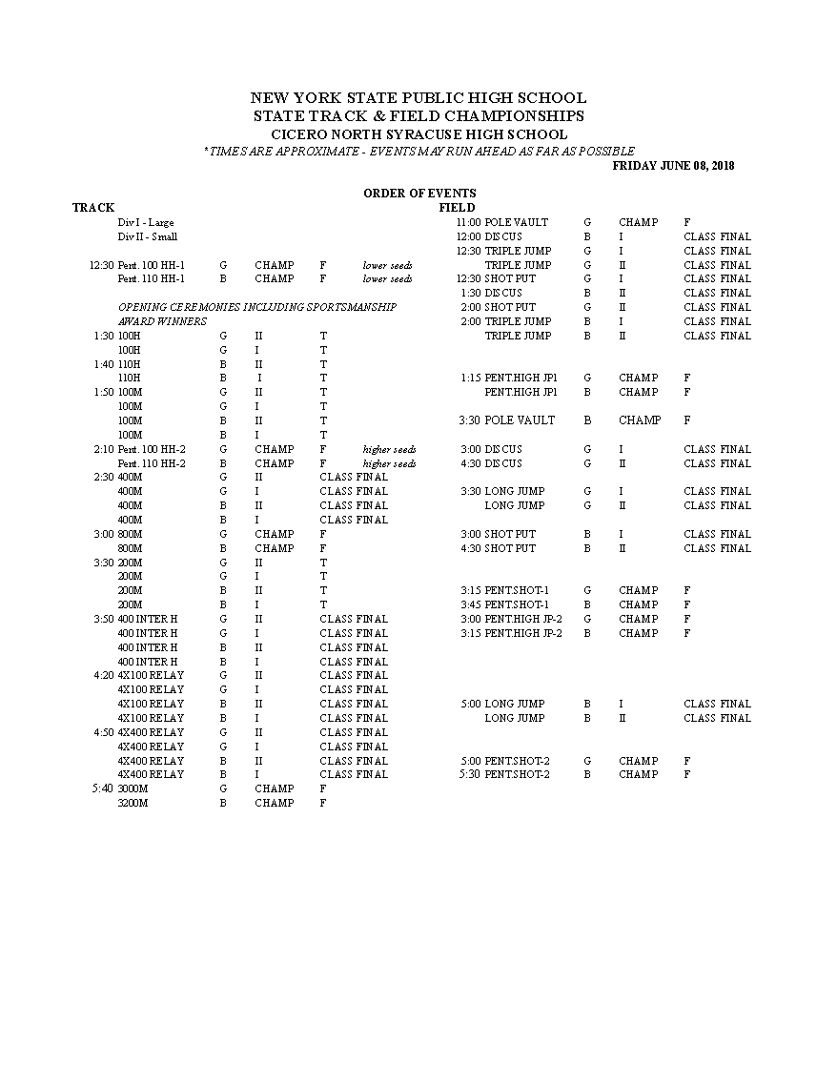

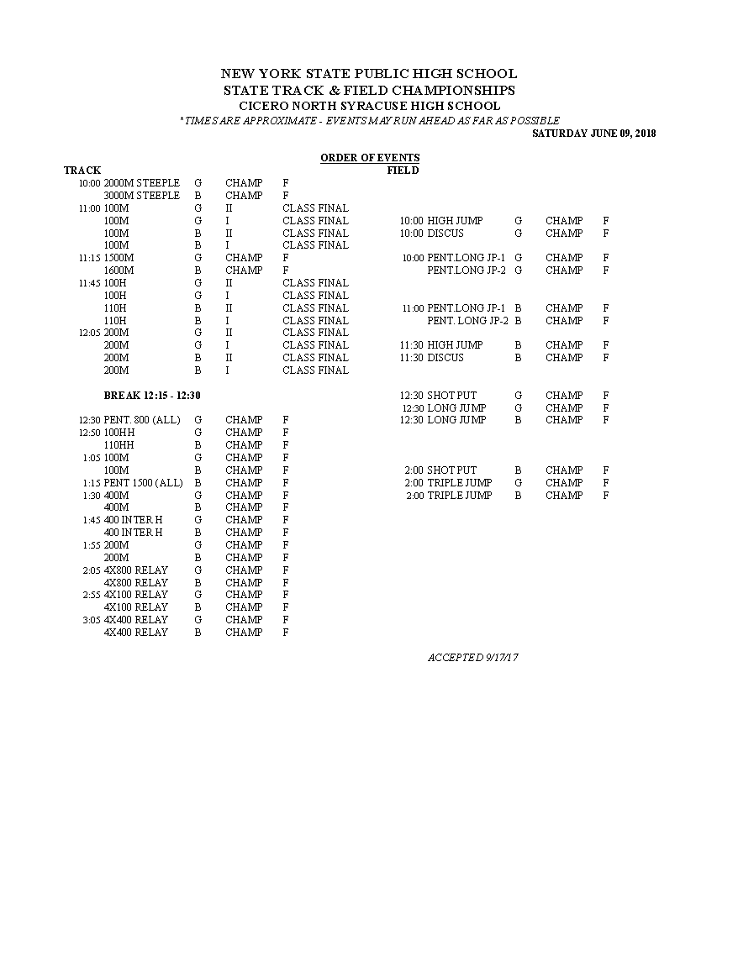

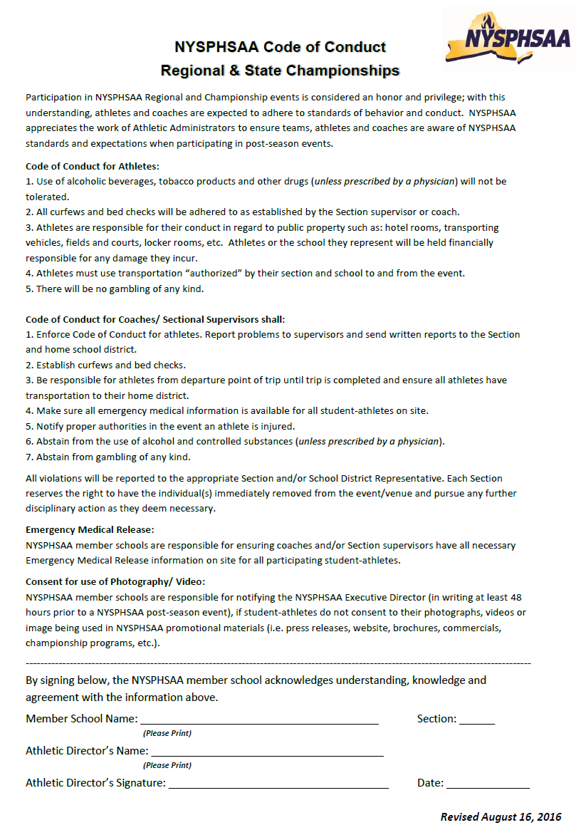

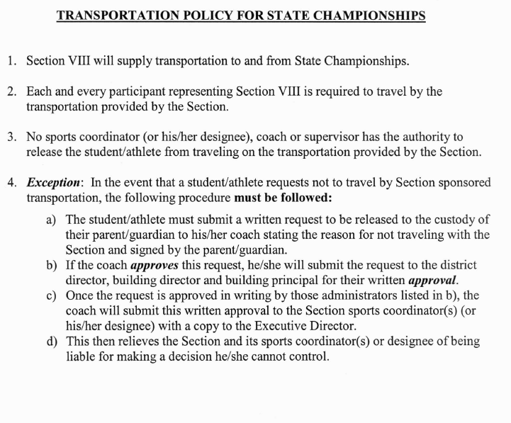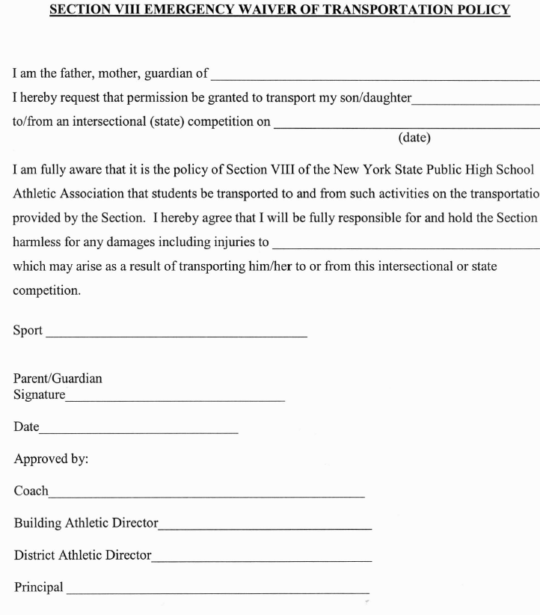

**Request for Medical Waiver of NYSPHSAA – Regulation #25**

To be eligible for sectional, intersectional or state competition, a team must have competed in six (6) school scheduled contests during the season. An individual is eligible for the team if he/she has been an eligible participant on a team in that sport in that school for a minimum of six (6) scheduled contests during the regular season. For football, a student must be an eligible participant for a minimum of three (3) contests. Contestants in individual sports (archery, badminton, bowling, cross country, fencing, golf, gymnastics, rifle, skiing, swimming tennis, outdoor track, winter track and wrestling) must also have represented their school in six (6) scheduled contests during the season to be eligible. These required contests must occur on six different dates and must be concluded prior to the conclusion of the team’s regular schedule.

School Sport

Athlete Date Request Submitted

Nature of Injury/Illness

Date of Injury/Onset of Illness Date of Medical Clearance

Record of Participation in Competitions (Exclusive of Section Tournaments):

*If Wrestler: Please include Weigh-in

Date Opponent validated by Athletic Director

1. ______________________ ____________________________________ *_________________________

2. ______________________ ____________________________________ * ________________________

3. ______________________ ____________________________________ * ________________________

4. ______________________ ____________________________________ * ________________________

5. ______________________ ____________________________________ *_________________________

Note:

All pertinent medical documentation must accompany this request before it will be considered. Such material MUST VERIFY the date of onset of the illness/injury and date physical activity may resume. NOTES FROM PHYSICAL THERAPISTS ARE NOT ACCEPTABLE.

Medical Documents Attached:

1. ___________________________________________ 3._________________________________________

2. ___________________________________________ 4. _________________________________________

**Request and documentation must be received by the sport coordinator and the Section VIII Office prior**

**to the last regular season contest.**

Signature of Athletic Director

Office of Interscholastic Athletics

George Farber Administrative Center

P.O. Box 9195 – 71 Clinton Road

Garden City, NY 11530-9195

Fax# 997-2916 – 997-2018

Approved by the Athletic Council - 2005

**Pole Vault Certification Form**

|  |  |
| --- | --- |
| School: | Date: |

|  |  |  |
| --- | --- | --- |
| Athlete: | | Weight: lbs. |
| Pole #1: | Length: | Rating: lbs. |
| Pole #2: | Length: | Rating: lbs. |
| Athlete Signature: | | Date: |

|  |  |  |
| --- | --- | --- |
| Athlete: | | Weight: lbs. |
| Pole #1: | Length: | Rating: lbs. |
| Pole #2: | Length: | Rating: lbs. |
| Athlete Signature: | | Date: |

|  |  |  |
| --- | --- | --- |
| Athlete: | | Weight: lbs. |
| Pole #1: | Length: | Rating: lbs. |
| Pole #2: | Length: | Rating: lbs. |
| Athlete Signature: | | Date: |

|  |  |
| --- | --- |
| Coach Signature: | Date: |

**NYS Public High School Athletic Association, Inc.**

**NY Track, Field and Cross Country Officials Association, Inc.**

**High School Track and Field: Pole Vault Certification Card**

Pole Vault Certification is required by the National Federation of State High School Associations, the governing body for high school athletics and officiating. Rule # 7-4-3 (effective 1995) states that a vaulter shall not be allowed to compete while using a pole which has rating of less than the vaulter’s actual weight. The purpose of this form is to ensure that the vaulter is competing with a legal pole at each competition. A copy of this form must be presented to both the official in charge and to the meet director before each competition begins. Make several copies and always have them on hand as the vaulter cannot compete without presenting this document.

It is the responsibility of the school to ensure that the pole being used is certified for the vaulter. The required signatures on this form are evidence that all parties are aware of the risks involved when an athlete competes with an illegal pole and that both the athlete and the pole are in compliance with the weight requirement rule. Complete a form each season for all poles that the vaulter will use in competition and whenever the vaulter gains weight to the extent that the listed rating is no longer valid.

**Safe pole vaulting practices include:**

Athletes....

1. Should always compete with the proper equipment.

2. Are prohibited from switching poles during competition unless certified for that pole.

3. Should not compete when suffering from an illness or any other ailment or when overtired.

4. Must continually inspect their pole for stress cracks, chips, etc. which might cause it to break during competition.

5. Must refrain from jumping when weather or other conditions might lead to an accident.

6. Must continually check the landing surface, planting box, and standards to ensure that they are in proper shape and/or adjustment.

7. Should not attempt heights for which they are not practiced at or in condition to jump for.

