Malverne High School
The Colbert Britt Memorial Invitational
Spring 2019

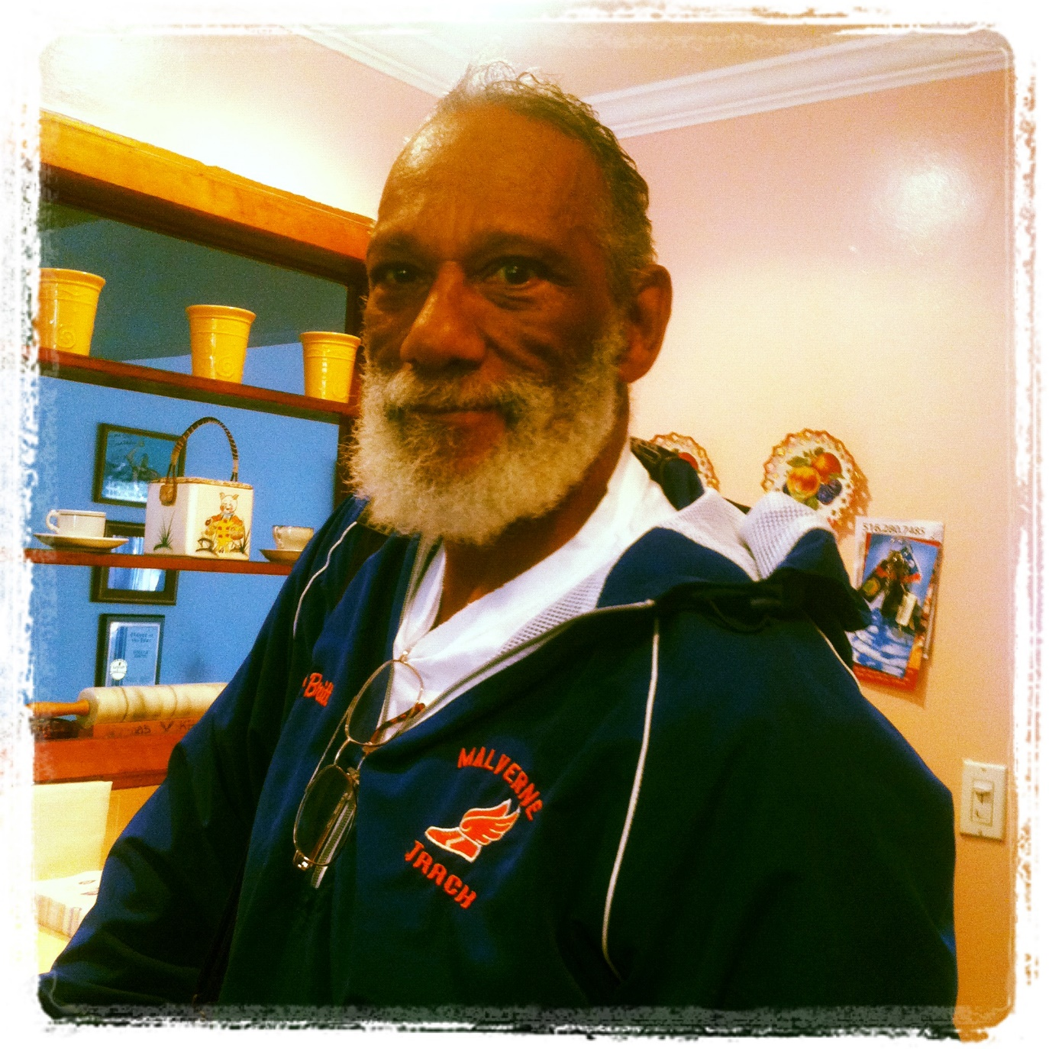

MALVERNE HIGH SCHOOL
Colbert Britt Memorial Invitational

The Lakeview Youth Federation and Malverne High School invite you to compete in the 1st annual Colbert Britt Memorial Invitational.

DATE: MONDAY, April 22, 2019 RAIN OR SHINE.

TIME: 10:00 am Field events and Running events Clerking begins at 9:45am

LOCATION: Malverne High School 80 Ocean Ave. Malverne, NY 11565

REGISTRATION & ENTRIES FEES:

BLANKET ENTRY FEE PER TEAM!!

NASSAU COUNTY PUBLIC SCHOOLS
$150.00 includes the cost of officials.
Official costs will be split between schools and billed through BOCES; the entry fee must be submitted separately.
(BOYS AND GIRLS CONSIDERED SEPARATE TEAMS)

NON-NASSAU COUNTY PUBLIC SCHOOLS
A Blanket entry fee per team of $175
(BOYS AND GIRLS CONSIDERED SEPARATE TEAMS)

** CHECK OR SCHOOL VOUCHER MUST ACCOMPANY ENTRY **
Payable to: Malverne Track and Field Booster Club
80 Ocean Ave.
Malverne, New York, 11565

PLEASE NOTE: This is an ENTRY fee, not a PARTICIPATION fee. Entry by mail, email, fax or phone denotes an obligation on your part to pay that fee whether or not you attend the MEET.

Entry Deadline: The closing date for all entries is Wednesday, April 17, 2019.

SEND INTENTIONS TO ABRITT07@GMAIL.COM

MALVERNE HIGH SCHOOL
Colbert Britt Memorial Invitational
NON – SECTION VIII PUBLIC SCHOOLS MUST SUBMIT A TEAM ROSTER FOR ALL INVITATIONAL AND FIELD EVENTS
Please submit your full roster online at just-in-time-racing.com. If you have never used this website, you will have to e-mail Tony Toro at eltorotf@optonline.net to get a password.

Once you get the password
- Go to www.just-in-time-racing.com
- Go to spring track
- Go to rosters (your athlete must be listed before you can seed them)
- Choose meet entries
- Once you’ve completed seeding your athletes save all entries at the bottom of the page. Seeding is required for all invitational events!
- Make a copy for your records

Section VIII Public school teams will use their Section VIII competitor number.
Non- Section VIII schools will be using numbers assigned by Tony Toro.

COACHES’ INFORMATION

ENTRIES
Due Date is Wednesday, April 17, 2019

ELIGIBILITY
An athlete may compete in any three events.

INVITATIONAL EVENTS
Please seed your athletes on just-in-time-racing.com.
We will accept ONLY the top 24 athletes in these events.

RELAYS
You do not have to seed your relays. Your relays will be seeded the day of the meet.

Relay seeded heats will be run in lanes. All others may be run from a common start.

FIELD EVENTS
Opening Heights:
Boys High Jump 5’ 0” Girls High Jump 4’ 0”

In the Long Jump, Shot Put and Discus each competitor will be given three (3) Jump / Throws. The top six (6) will come back for a Final three (3) Jump / Throws.

Frosh/ Soph athletes will compete after the Open Finals.

AWARDS
Trophies and T-Shirts to the top three in Invitational Events.
Medal and T-Shirts to the First Place Team in each relay and Medals to 2nd and 3rd.
Medals to the top three in the individual events.

MEET GUIDELINES

1. Sanctioned by Nassau County Section VIII Athletic Council.
2. National Federation Rules will govern, with NYSPHSAA modifications: 3 Event Rule and No False Start Rules will be in effect for both boys and girls.
3. All weather track and runaways.
Flat or pin spikes may be worn no longer than ¾” (others will be disqualified.)
4. Arrive in uniform. No dressing facilities.
5. All spectators and athletes must remain in the bleachers, not on the infield.
Upon completion of their event, all athletes must leave the infield.
6. Awards will be picked up by coaches only
7. All relay teams must wear identical uniforms.
8. A school may enter an unlimited amount of teams per relay.
9. All relays will be run in sections. Seed sections go first.
10. Relay cards and seed times will be submitted to the clerk when event is called.
11. Please supply your own baton, Starting blocks.

Meet Directors: Onix Salva and Alma Britt

Questions Contact: OnixSalva@gmail.com

This meet is sponsored by Malverne High School and enforces all National Federation, NYSPHAA, and Section VIII rules.
MALVERNE HIGH SCHOOL COLBERT BRITT MEMORIAL INVITE

BOYS ENTRY _________ GIRLS ENTRY _________

School Name ______________________________________ Phone # __________________

School Address ___________________________________________________________________________

Coach’s Name ___________________________________ Coach’s Email__________________________

Coach’s Phone #________________________ Athletic Director Signature __________________________

RELAYS INDIVIDUAL EVENTS
OPEN # of Teams # of Athletes
Sprint Medley Relay 100m Dash _______
(100m – 100m – 200m – 400m) ________
800m Run _______

4x400 Mixed Relay ________ High Jump _______ Shot Put _______
4x100 Meter Relay ________
4x200 Meter Relay ________ Discus _______
4x400 Meter Relay ________ Long Jump ________
4x 800 Meter Relay ________

Fresh / Soph
4x200 Meter Relay ________
4x400 Meter Relay ________

INVITATIONAL EVENTS
Top 16 – 24 ATHLETES WILL BE ACCEPTED

1600m / 1500m Run ________ 110m / 100m H.H ________

400m I. Hurdles ________

ENTRIES ARE DUE BY Wednesday, April 17, 2017
CHECKS PAYABLE TO: Malverne Track and Field Booster Club
MAIL TO: 80 Ocean Ave.~ Malverne, New York 11565
MALVERNE HIGH SCHOOL COLBERT BRITT MEMORIAL INVITATIONAL
ORDER OF EVENTS

10:00 am

1 100m H. Hurdles Invitational Girls Final
2 110m H. Hurdles Invitational Boys Final
3 100m Dash Girls Semi – Final
100m Dash Boys Semi – Final
4 Mixed 4 x 400m Relay Final
(Girl, Boy, Girl, Boy)
5 1500m Run Invitational Girls Final
6 4 x 100m Relay Girls Semi – Final
7 4 x 100m Relay Boys Semi – Final
8 800m Run Girls Final
9 800m Run Boys Final
OPENING CEREMONY – NATIONAL ANTHEM
10 100m Girls Final
11 100m Boys Final
12 400m Dash Girls Final
13 400m Dash Boys Final
14 1600m Run Invitational Boys Final
15 Sprint Medley Relay Girls Final
(200m -100m -100m -400m)
16 Sprint Medley Relay Boys Final
(200m -100m -100m -400m)
17 4 x 800m Relay Girls Final
18 4 x 800m Relay Boys Final
19 4 x 200m Relay Girls Final
20 4 x 200m Relay FROSH/SOPH Girls Final
21 4 x 200m Relay Boys Final
22 4 x 200m Relay FROSH/SOPH Boys Final
23 400m I. Hurdles Invitational Girls Final
24 400m I. Hurdles Invitational Boys Final
25 4 x 400m Relay Girls Final
26 4 x 400m Relay FROSH/SOPH Girls Final
27 4 x 400m Relay Boys Final
28 4 x 400m Relay FROSH/SOPH Boys Final
29 4 x 100m Relay Girls Final
30 4 x 100m Relay Boys Final

FIELD EVENTS
10:00 am

SHOT PUT: GIRLS / BOYS LONG JUMP: BOYS / GIRLS

DISCUS: BOYS / GIRLS HIGH JUMP: GIRLS / BOYS

*FROSH/ SOPH will follow Open Finals for ALL Field Events

